**Mẫu bìa ĐA/KLTN:** in chữ nhũ, mạ vàng, Bìa cứng màu đỏ, khổ 210 x 297 mm

*Mẫu QT.ĐT.19.M07*

|  |  |
| --- | --- |
|  |  |
| HỌ VÀ TÊN SINH VIÊN | **BỘ GIÁO DỤC VÀ ĐÀO TẠO**  **TRƯỜNG ĐẠI HỌC PHENIKAA** |
| logo trường - dọc  **ĐỒ ÁN/KHÓA LUẬN TỐT NGHIỆP** |
| **ỨNG DỤNG MÔ HÌNH NGÔN NGỮ LỚN TRONG ĐIỂU KHIỂN ROBOT CÔNG NGHIỆP** |
| NGÀNH | **Sinh viên: LÊ TIẾN ĐẠT** |
| **Mã số sinh viên: 19010205Khóa: K13**  **Ngành: Kĩ thuật điều khiển và tự động hóa Hệ: Chính quy**  **Giảng viên hướng dẫn: TS. Lê Minh Huy** |
|  |
|  |
| **Hà Nội – Năm 2024** |

**TRANG PHỤ BÌA**

*Mẫu QT.ĐT.19.M07*

|  |
| --- |
| **BỘ GIÁO DỤC VÀ ĐÀO TẠO**  **TRƯỜNG ĐẠI HỌC PHENIKAA** |
| logo trường - dọc  **ĐỒ ÁN/KHÓA LUẬN TỐT NGHIỆP** |
| **ỨNG DỤNG MÔ HÌNH NGÔN NGỮ LỚN**  **TRONG ĐIỂU KHIỂN ROBOT CÔNG NGHIỆP** |
| **Sinh viên: LÊ TIẾN ĐẠT** |
| **Mã số sinh viên: 19010205 Khóa: K13**  **Ngành: *Kĩ thuật điều khiển và tự động hóa* Hệ: Chính quy**  **Giảng viên hướng dẫn: TS. Lê Minh Huy** |
| **Hà Nội – Năm** |
|  |
| *Mẫu QT.ĐT.18.M04*  *Mẫu QT.ĐT.19.M07* |

**LỜI CAM ĐOAN**

Tên tôi là: ………………………………………………………………………….........

Mã sinh viên: ………………………….. Lớp: …………………………………….......

Ngành: ……………………………………………………………………………… …..

Tôi đã thực hiện đồ án/khóa luận tốt nghiệp với đề tài: ………………………………...

…………………………………………………………………………………………...

Tôi xin cam đoan đây là đề tài nghiên cứu của riêng tôi và được sự hướng dẫn của: …………………………………………………………………………………….

Các nội dung nghiên cứu, kết quả trong đề tài này là trung thực và chưa được các tác giả khác công bố dưới bất kỳ hình thức nào. Nếu phát hiện có bất kỳ hình thức gian lận nào tôi xin hoàn toàn chịu trách nhiệm trước pháp luật.

|  |  |
| --- | --- |
| **GIẢNG VIÊN HƯỚNG DẪN**  *(Ký, ghi rõ họ tên)* | *Hà Nội, ngày … tháng … năm 20…*  **SINH VIÊN**  *(Ký, ghi rõ họ tên)* |

*Mẫu QT.ĐT.19.M08*

|  |  |
| --- | --- |
| BỘ GIÁO DỤC VÀ ĐÀO TẠO  **TRƯỜNG ĐẠI HỌC PHENIKAA** | **CỘNG HOÀ XÃ HỘI CHỦ NGHĨA VIỆT NAM**  **Độc lập - Tự do - Hạnh phúc** |

**NHẬN XÉT ĐỒ ÁN/KHÓA LUẬN TỐT NGHIỆP**

**CỦA GIẢNG VIÊN HƯỚNG DẪN**

Giảng viên hướng dẫn: ................................................................. Bộ môn:

Tên đề tài:

Sinh viên thực hiện: ..................................................................... Lớp:

NỘI DUNG NHẬN XÉT

**I. Nhận xét ĐAKLTN:**

- Nhận xét về hình thức: ………………………………………………………………...

…………………………………………………………………………………………...

- Tính cấp thiết của đề tài: ………………………………………………………………

…………………………………………………………………………………………...

- Mục tiêu của đề tài: ……………………………………………………………………

…………………………………………………………………………………………...

- Nội dung của đề tài: …………………………………………………………………...

…………………………………………………………………………………………...

- Tài liệu tham khảo: ……………………………………………………………………

…………………………………………………………………………………………...

- Phương pháp nghiên cứu: ……………………………………………………………..

…………………………………………………………………………………………...

- Tính sáng tạo và ứng dụng: ……………………………………………………………

…………………………………………………………………………………………...

**II. Nhận xét tinh thần và thái độ làm việc của sinh viên:**

…………………………………………………………………………………………..

…………………………………………………………………………………………..

…………………………………………………………………………………………..

…………………………………………………………………………………………..

**III. Kết quả đạt được:**

…………………………………………………………………………………………..

…………………………………………………………………………………………..

…………………………………………………………………………………………..

…………………………………………………………………………………………...

**IV. Kết luận:** Đồng ý cho bảo vệ: Không đồng ý cho bảo vệ:

*Hà Nội, ngày … tháng … năm 20…*

**GIẢNG VIÊN HƯỚNG DẪN**

*(Ký, ghi rõ họ tên)*

*Mẫu QT.ĐT.19.M09*

|  |  |
| --- | --- |
| BỘ GIÁO DỤC VÀ ĐÀO TẠO  **TRƯỜNG ĐẠI HỌC PHENIKAA** | **CỘNG HOÀ XÃ HỘI CHỦ NGHĨA VIỆT NAM**  **Độc lập - Tự do - Hạnh phúc** |

**NHẬN XÉT ĐỒ ÁN/KHÓA LUẬN TỐT NGHIỆP**

**CỦA GIẢNG VIÊN PHẢN BIỆN**

Giảng viên phản biện: ................................................................. Bộ môn:

Tên đề tài:

Sinh viên thực hiện: .................................................................... Lớp:

Giảng viên hướng dẫn:

NỘI DUNG NHẬN XÉT

**I. Nhận xét ĐAKLTN:**

- Bố cục, hình thức trình bày:

- Đảm bảo tính cấp thiết, hiện đại, không trùng lặp:

- Nội dung:

- Mức độ thực hiện:

**II. Kết quả đạt được:**

**III. Ưu như­ợc điểm:**

**IV. Kết luận:** Đồng ý cho bảo vệ: Không đồng ý cho bảo vệ:

*Hà Nội, ngày......tháng.......năm 20.....*

**GIẢNG VIÊN PHẢN BIỆN**

*(Ký, ghi rõ họ tên)*

*Mẫu QT.ĐT.19.M12*

**CỘNG HÒA XÃ HỘI CHỦ NGHĨA VIỆT NAM**

**Độc lập – Tự do – Hạnh phúc**

**BẢN CAM KẾT**

**Về việc tham gia bảo vệ đồ án/khóa luận tốt nghiệp theo hình thức trực tuyến**

Kính gửi: - Ban Giám hiệu trường Đại học Phenikaa;

- Phòng Đào tạo;

- Khoa ……………………………………

Em tên là: …………………………….. Mã SV: ……………………………...

Là sinh viên Khoa: …………………… Ngành: ………………………………

Khóa: ………………………………… Lớp: …………………………………

**Em xin cam kết các nội dung sau đây:**

1. Em đồng ý tham gia bảo vệ đồ án/khóa luận tốt nghiệp theo hình thức trực tuyến do Trường Đại học Phenikaa tổ chức;

2. Em cam kết thực hiện bảo vệ đồ án/khóa luận tốt nghiệp trực tuyến đảm bảo trung thực, khách quan và theo đúng quy định của Nhà trường.

Em chịu hoàn toàn trách nhiệm về tính chính xác của thông tin và những nội dung cam kết nêu trên.

*Hà Nội, ngày … tháng … năm 20..*

**Sinh viên**

*(Ký, ghi rõ họ tên)*

*Mẫu QT.ĐT.19.M13*

|  |
| --- |
|  |

**CỘNG HÒA XÃ HỘI CHỦ NGHĨA VIỆT NAM  
Độc lập - Tự do - Hạnh phúc**

**GIẤY XÁC NHẬN**

**THAM GIA HỌP ĐÁNH GIÁ ĐỒ ÁN/KHÓA LUẬN TỐT NGHIỆP**

**THEO HÌNH THỨC TRỰC TUYẾN**

|  |  |
| --- | --- |
| Kính gửi: | - Ban Giám hiệu trường Đại học Phenikaa;  - Phòng Đào tạo;  - Khoa ……………………………………... |

Tôi là: ……………………………………………………………………………

Số điện thoại:…………………….. Email:………………………………………

Là Chủ tịch/Phản biện/Thư ký/Ủy viên của Hội đồng đánh giá đồ án/khóa luận tốt nghiệp cho sinh viên ……………………………………………………………

Chuyên ngành…………………………………………………………………….

Tôi đã đọc và có nhận xét về đồ án/khóa luận tốt nghiệp của sinh viên.

Tôi đồng ý tham gia họp đánh giá đồ án/khóa luận tốt nghiệp cho sinh viên theo hình thức trực tuyến vào hồi … giờ … ngày … tháng … năm 20... /.

*…………., ngày … tháng … năm 20..*

**THÀNH VIÊN HỘI ĐỒNG**

*(Ký, ghi rõ họ tên)*

*Mẫu QT.ĐT.19.M14*

|  |  |
| --- | --- |
| BỘ GIÁO DỤC VÀ ĐÀO TẠO  **TRƯỜNG ĐẠI HỌC PHENIKAA** | **CỘNG HOÀ XÃ HỘI CHỦ NGHĨA VIỆT NAM**  **Độc lập - Tự do - Hạnh phúc** |

**PHIẾU ĐÁNH GIÁ ĐỒ ÁN/KHÓA LUẬN TỐT NGHIỆP**

**CỦA GIẢNG VIÊN HƯỚNG DẪN**

**I. THÔNG TIN CHUNG**

Người đánh giá: …………….......….. Học hàm, học vị: …………................…………

Đơn vị công tác: …………...........................……………………………………...…….

Họ tên sinh viên: ..….....................…… Mã SV: ……………..... Ngành: ……………..

Tên đề tài: ……………………….......................……………………………….............

………………………………………………….....................………………………….

**II. ĐÁNH GIÁ** *(Điểm từng tiêu chí và điểm cuối cùng làm tròn đến 1 chữ số thập phân)*

|  |  |  |  |
| --- | --- | --- | --- |
| **TT** | **Nội dung đánh giá** | **Điểm tối đa** | **Điểm đánh giá** |
| 1 | Ý thức và thái độ của sinh viên trong quá trình thực hiện đề tài | 1,0 |  |
| 2 | Khả năng xử lý, giải quyết vấn đề của sinh viên trong thực hiện đề tài | 1,0 |  |
| 3 | Hình thức trình bày quyển, thuyết minh và bản vẽ (theo quy định của Nhà trường, không có lỗi chính tả, ngắn gọn, mạch lạc, súc tích ...) | 1,5 |  |
| 4 | Thực hiện các nội dung của đề tài (về nội dung chuyên môn và khoa học cũng như về phương pháp nghiên cứu, xử lý vấn đề của ĐAKLTN có gì đúng, sai, có gì mới, mức độ sáng tạo) | 4,5 |  |
| 5 | Mối liên hệ với những vấn đề liên quan (cơ sở lý thuyết và các hướng nghiên cứu khác có liên quan) | 1,0 |  |
| 6 | Tính ứng dụng thực tiễn (phạm vi và mức độ ứng dụng, triển vọng của đề tài, tính mới, tính sáng tạo ...) | 1,0 |  |
| **Tổng số** | | **10,0** |  |

**III. NHẬN XÉT**

………………………………………………….....................………………………….

………………………………………………….....................………………………….

*Hà Nội, ngày … tháng … năm 20…*

**GIẢNG VIÊN HƯỚNG DẪN**

*(Ký, ghi rõ họ tên)*

*Mẫu QT.ĐT.19.M15*

|  |  |
| --- | --- |
| BỘ GIÁO DỤC VÀ ĐÀO TẠO  **TRƯỜNG ĐẠI HỌC PHENIKAA** | **CỘNG HOÀ XÃ HỘI CHỦ NGHĨA VIỆT NAM**  **Độc lập - Tự do - Hạnh phúc** |

**PHIẾU ĐÁNH GIÁ ĐỒ ÁN/KHÓA LUẬN TỐT NGHIỆP**

**CỦA GIẢNG VIÊN PHẢN BIỆN CHẤM QUYỂN**

**I. THÔNG TIN CHUNG**

Người đánh giá: …………….......….. Học hàm, học vị: ………................……………

Đơn vị công tác: .………...........................……………………………………...………

Họ tên sinh viên: ..….....................…… Mã SV: ……………..... Ngành: ……………..

Tên đề tài: …………………….......................………………………………..................

………………………………………………….....................…………………………..

**II. ĐÁNH GIÁ** *(Điểm từng tiêu chí và điểm cuối cùng làm tròn đến 1 chữ số thập phân)*

|  |  |  |  |
| --- | --- | --- | --- |
| **TT** | **Nội dung đánh giá** | **Điểm tối đa** | **Điểm đánh giá** |
| 1 | Hình thức trình bày quyển, thuyết minh và bản vẽ (theo quy định của Nhà trường, không có lỗi chính tả, ngắn gọn, mạch lạc, súc tích ...) | 1,5 |  |
| 2 | Thực hiện các nội dung của đề tài (về nội dung chuyên môn và khoa học cũng như về phương pháp nghiên cứu, xử lý vấn đề của ĐAKLTN có gì đúng, sai, có gì mới, mức độ sáng tạo). | 4,5 |  |
| 3 | Mối liên hệ với những vấn đề liên quan (cơ sở lý thuyết và các hướng nghiên cứu khác có liên quan) | 2,0 |  |
| 4 | Tính ứng dụng thực tiễn (phạm vi và mức độ ứng dụng, triển vọng của đề tài, tính mới, tính sáng tạo ...) | 2,0 |  |
| **Tổng số** | | **10,0** |  |

**III. NHẬN XÉT**

………………………………………………….....................………………………….

………………………………………………….....................………………………….

*Hà Nội, ngày … tháng … năm 20…*

**GIẢNG VIÊN PHẢN BIỆN**

*(Ký, ghi rõ họ tên)*

*Mẫu QT.ĐT.19.M16*

|  |  |
| --- | --- |
| BỘ GIÁO DỤC VÀ ĐÀO TẠO  **TRƯỜNG ĐẠI HỌC PHENIKAA** | **CỘNG HOÀ XÃ HỘI CHỦ NGHĨA VIỆT NAM**  **Độc lập - Tự do - Hạnh phúc** |

**PHIẾU ĐÁNH GIÁ ĐỒ ÁN/KHÓA LUẬN TỐT NGHIỆP**

**CỦA THÀNH VIÊN HỘI ĐỒNG**

**I. THÔNG TIN CHUNG**

Người đánh giá: …………….......….. Học hàm, học vị: ………................……………

Đơn vị công tác: ………...........................……………………………………...……….

Họ tên sinh viên: ..….....................…… Mã SV: ……………..... Ngành: ……………..

Tên đề tài: ……………………….......................………………………………..............

………………………………………………….....................…………………………..

**II. ĐÁNH GIÁ** *(Điểm từng tiêu chí và điểm cuối cùng làm tròn đến 1 chữ số thập phân)*

|  |  |  |  |
| --- | --- | --- | --- |
| **TT** | **Nội dung đánh giá** | **Điểm tối đa** | **Điểm đánh giá** |
| 1 | Trình bày nội dung (slide rõ ràng, ngắn gọn, đầy đủ, đúng giờ) | 0,5 |  |
| 2 | Trả lời các câu hỏi của giảng viên phản biện | 1,5 |  |
| 3 | Trả lời các câu hỏi của thành viên hội đồng | 1,5 |  |
| 4 | Tinh thần, thái độ và cách ứng xử | 1,0 |  |
| 5 | Thực hiện các nội dung của đề tài (về nội dung chuyên môn và khoa học cũng như về phương pháp nghiên cứu, xử lý vấn đề của ĐAKLTN có gì đúng, sai, có gì mới, mức độ sáng tạo) | 4,5 |  |
| 6 | Mối liên hệ với những vấn đề liên quan (cơ sở lý thuyết và các hướng nghiên cứu khác có liên quan) | 1,0 |  |
| **Tổng số** | | **10,0** |  |

**III. NHẬN XÉT**

………………………………………………….....................………………………….

………………………………………………….....................………………………….

*Hà Nội, ngày … tháng … năm 20…*

**THÀNH VIÊN HỘI ĐỒNG**

*(Ký, ghi rõ họ tên)*

*Mẫu QT.ĐT.19.M17*

|  |  |
| --- | --- |
| BỘ GIÁO DỤC VÀ ĐÀO TẠO  **TRƯỜNG ĐẠI HỌC PHENIKAA** | **CỘNG HOÀ XÃ HỘI CHỦ NGHĨA VIỆT NAM**  **Độc lập - Tự do - Hạnh phúc** |

**PHIẾU CHẤM ĐỒ ÁN/KHÓA LUẬN TỐT NGHIỆP**

**CỦA GIẢNG VIÊN CHẤM ….(Vòng chấm …..)**

**I. THÔNG TIN CHUNG**

Người chấm: …………….......….. Học hàm, học vị: ………................……………

Đơn vị công tác: .………...........................……………………………………...………

Họ tên sinh viên: ..….....................…… Mã SV: ……………..... Ngành: ……………..

Tên đề tài: …………………….......................………………………………..................

………………………………………………….....................…………………………..

**II. ĐÁNH GIÁ** *(Điểm từng tiêu chí và điểm cuối cùng làm tròn đến 1 chữ số thập phân)*

|  |  |  |  |
| --- | --- | --- | --- |
| **TT** | **Nội dung đánh giá** | **Điểm tối đa** | **Điểm đánh giá** |
| 1 | Hình thức trình bày quyển, thuyết minh và bản vẽ (theo quy định của Nhà trường, không có lỗi chính tả, ngắn gọn, mạch lạc, súc tích ...) | 1,5 |  |
| 2 | Thực hiện các nội dung của đề tài (về nội dung chuyên môn và khoa học cũng như về phương pháp nghiên cứu, xử lý vấn đề của ĐAKLTN có gì đúng, sai, có gì mới, mức độ sáng tạo). | 4,5 |  |
| 3 | Mối liên hệ với những vấn đề liên quan (cơ sở lý thuyết và các hướng nghiên cứu khác có liên quan) | 2,0 |  |
| 4 | Tính ứng dụng thực tiễn (phạm vi và mức độ ứng dụng, triển vọng của đề tài, tính mới, tính sáng tạo ...) | 2,0 |  |
| **Tổng số** | | **10,0** |  |

**III. NHẬN XÉT**

………………………………………………….....................………………………….

………………………………………………….....................………………………….

*Hà Nội, ngày … tháng … năm 20…*

**GIẢNG VIÊN CHẤM ….**

*(Ký, ghi rõ họ tên)*

*Mẫu QT.ĐT.19.M18*

|  |  |
| --- | --- |
| BỘ GIÁO DỤC VÀ ĐÀO TẠO  **TRƯỜNG ĐẠI HỌC PHENIKAA** | **CỘNG HOÀ XÃ HỘI CHỦ NGHĨA VIỆT NAM**  **Độc lập - Tự do - Hạnh phúc** |

**BIÊN BẢN ĐÁNH GIÁ ĐỒ ÁN/KHÓA LUẬN TỐT NGHIỆP**

**I. Thông tin chung**

1. Thời gian: từ … giờ … đến … giờ … ngày … / … /20…

2. Địa điểm: ………………………………………………………………………

3. Họ tên sinh viên: ………………………………… Mã SV: ………………….

4. Lớp: ……………….. Ngành: ……………………… … Khóa: ……………...

5. Tên đề tài: ……………………………………………………………………..

6. Giảng viên hướng dẫn: ………………………………………………………..

**II. Thành phần**

1. …………………………………….……. Chủ tịch

2. ………………………………………….. Thư ký

3. ………………………………………….. Giảng viên phản biện

……………………………………………... Ủy viên 1

**III. Tổng hợp câu hỏi của thành viên Hội đồng**

…………………………………………………………………………………………...…………………………………………………………………………………………...

…………………………………………………………………………………………...

…………………………………………………………………………………………...

…………………………………………………………………………………………...

…………………………………………………………………………………………...

**IV. Tổng hợp nội dung trả lời của sinh viên**

…………………………………………………………………………………………...

…………………………………………………………………………………………...

…………………………………………………………………………………………...

…………………………………………………………………………………………...…………………………………………………………………………………………...

…………………………………………………………………………………………...

**V. Nội dung đánh giá của Hội đồng**

1. Ý nghĩa của đồ án/khóa luận: ……...............................................................

2. Về nội dung, kết cấu của đồ án/khóa luận: ………………………………...

3. Phương pháp nghiên cứu: ………………………………………………….

4. Các kết quả nghiên cứu đạt được: ………………………………………….

5. Những ưu điểm, nhược điểm và nội dung cần bổ sung, chỉnh sửa: ………..

**VI. Điểm kết luận:** ………………… *(Bằng chữ: ………………………)*

|  |  |
| --- | --- |
| **CHỦ TỊCH HỘI ĐỒNG**  *(Ký, ghi rõ họ tên)* | **THƯ KÝ**  *(Ký, ghi rõ họ tên)* |

*Mẫu QT.ĐT.19.M19*

|  |  |
| --- | --- |
| BỘ GIÁO DỤC VÀ ĐÀO TẠO  **TRƯỜNG ĐẠI HỌC PHENIKAA** | **CỘNG HOÀ XÃ HỘI CHỦ NGHĨA VIỆT NAM**  **Độc lập - Tự do - Hạnh phúc** |

**BIÊN BẢN CHẤM ĐỒ ÁN/KHÓA LUẬN TỐT NGHIỆP**

**I. Thông tin chung**

1. Thời gian: hôm nay, vào lúc … giờ … ngày … tháng … năm 20…

2. Địa điểm: tại Trường Đại học Phenikaa, căn cứ Quyết định số …/QĐ-ĐHP-ĐT ngày … tháng … năm 20… của Hiệu trưởng trường Đại học Phenikaa về việc thành lập Hội đồng chấm ĐAKLTN, Hội đồng đã tổ chức chấm cho:

3. Sinh viên: …………………………………… Mã sinh viên: ………………….

4. Lớp: ………………………………………… Khóa: …………………………..

5. Tên đề tài: ………………………………………………………………………

6. Giảng viên hướng dẫn: …………………………………………………………

**II. Thành phần**

1. ……………………………………………... Giảng viên chấm 1

2. ……………………………………………... Giảng viên chấm 2

**III. Kết quả nhận xét của giảng viên chấm ĐAKLTN**

1. Ý nghĩa của ĐAKLTN: ………………………………………………………………

…………………………………………………………………………………………...

2. Về nội dung, kết cấu của ĐAKLTN: …………………………………………………

…………………………………………………………………………………………...

…………………………………………………………………………………………...

3. Phương pháp nghiên cứu: …………………………………………………………….

…………………………………………………………………………………………...

4. Các kết quả nghiên cứu đạt được: ……………………………………………………

…………………………………………………………………………………………...

…………………………………………………………………………………………...

5. Những ưu, nhược điểm: ………………………………………………………………

…………………………………………………………………………………………...

…………………………………………………………………………………………...

**IV. Kết quả chấm điểm của giảng viên chấm ĐAKLTN**

|  |  |  |  |  |
| --- | --- | --- | --- | --- |
| **ĐIỂM SỐ CỦA CÁC THÀNH VIÊN** | | | **ĐIỂM TỔNG KẾT**  **[(1)+(2)+(3)]/3** | **Ghi chú** |
| **GV**  **HƯỚNG DẪN**  **(1)** | **GV**  **CHẤM 1**  **(2)** | **GV**  **CHẤM 2**  **(3)** |
|  |  |  |  |  |

**V. Điểm kết luận: ……. (Bằng chữ: …..)**

|  |  |  |
| --- | --- | --- |
| **GV HƯỚNG DẪN**  *(Ký, ghi rõ họ tên)* | **GV CHẤM 1**  *(Ký, ghi rõ họ tên)* | **GV CHẤM 2**  *(Ký, ghi rõ họ tên)* |

CỘNG HÒA XÃ HỘI CHỦ NGHĨA VIỆT NAM  
Độc lập - Tự do - Hạnh phúc

*Mẫu QT.ĐT.19.M22*

**BẢN GIẢI TRÌNH SỬA CHỮA ĐỒ ÁN/KHÓA LUẬN TỐT NGHIỆP**

Kính gửi: **-** Hội đồng đánh giá đồ án/khóa luận tốt nghiệp;

- Khoa

Họ và tên tác giả đồ án/khoá luận: ………………………………………………….....

Mã sinh viên:……………………. Lớp:……………………………………………….

Ngành: …………………………………………………………………………………

Đã bảo vệ đồ án/khóa luận tốt nghiệp ngày …. tháng …. năm 20…

Tên đề tài: ……………………………………………………………………………...

Giảng viên hướng dẫn: ………………………………………………………………...

Theo góp ý của Hội đồng, dưới sự định hướng của giảng viên hướng dẫn, tác giả đồ án/khoá luận đã nghiêm túc tiếp thu những ý kiến đóng góp của Hội đồng và tiến hành sửa chữa, bổ sung đồ án/khoá luận theo đúng tinh thần kết luận của Hội đồng. Chi tiết về các nội dung chỉnh sửa như sau:

1. Tác giả chỉnh sửa và bổ sung đồ án/khóa luận theo góp ý của Hội đồng

|  |  |  |  |
| --- | --- | --- | --- |
| **Nội dung** | **Trang cũ** | **Sửa thành** | **Trang mới** |
|  |  |  |  |
|  |  |  |  |

2. Tác giả xin được giữ quan điểm của mình ở một số nội dung đồ án/khoá luận

|  |  |  |
| --- | --- | --- |
| **Nội dung** | **Lý do giữ quan điểm của mình** | **Trang** |
|  |  |  |
|  |  |  |

Trên đây là Bản giải trình về những điểm sửa chữa, bổ sung đồ án/khoá luận của tác giả theo đúng yêu cầu của Hội đồng đánh giá ĐAKLTN ngành ..

tại Trường Đại học Phenikaa ngày … tháng … năm …

|  |  |  |
| --- | --- | --- |
| **CHỦ TỊCH HỘI ĐỒNG**  *(Ký, ghi rõ họ tên)* | **GV HƯỚNG DẪN**  *(Ký, ghi rõ họ tên)* | *Hà Nội, ngày … tháng … năm 20…*  **TÁC GIẢ**  *(Ký, ghi rõ họ tên)* |

|  |  |
| --- | --- |
| TRƯỜNG ĐẠI HỌC PHENIKAA  **KHOA …** | **CỘNG HÒA XÃ HỘI CHỦ NGHĨA VIỆT NAM**  ***Độc lập – Tự do – Hạnh phúc*** |

*Mẫu QT.ĐT.19.M23*

**THÔNG TIN ĐỒ ÁN/KHÓA LUẬN TỐT NGHIỆP**

- Ngành: …………………………………………………………………………………

- Lớp: ……………………………………………………………………………………

- Hệ đào tạo: …………………………………………………………………………….

- Niên khóa đào tạo: …………………………………………………………………….

|  |  |  |  |  |  |  |
| --- | --- | --- | --- | --- | --- | --- |
| **TT** | **Mã**  **sinh viên** | **Họ và tên** | **Ngày sinh** | **Tên đề tài** | **Tóm tắt đề tài** | **GV hướng dẫn** |
|  |  |  |  |  |  |  |
|  |  |  |  |  |  |  |
|  |  |  |  |  |  |  |
|  |  |  |  |  |  |  |
|  |  |  |  |  |  |  |
|  |  |  |  |  |  |  |

|  |  |
| --- | --- |
| **Trưởng Khoa**  *(Ký, ghi rõ họ tên)* | *Hà Nội, ngày … tháng … năm 20…*  **Người lập**  *(Ký, ghi rõ họ tên)* |

# Table of content

Table of content 1

ABSTRACT 1

Acknowledgement 2

I. INTRODUCTION 3

II. LITERATURE REVIEW 7

2.1. LLM 7

2.2. Qwen LLM models 8

2.3. Fine-tuning LLM models 11

2.4. Universal Robot ecosystem 12

2.4.1. URScript: Flexible Robotic Programming Language 12

2.4.2. URSim: Virtual Robotic Simulation Platform 13

2.5. UR robots 14

2.5.1. UR3 14

2.5.2. UR remote control via TCP 15

III. METHODOLOGY 17

3.1. Data collection 17

3.2. Fine-tune model 19

3.3. Testing 20

3.3.1. Test case 1 22

3.3.2. Test case 2 23

3.3.3. Test case 3 24

3.3.4. Test case 4 25

3.3.5. Test case 5 27

IV. EXPERIMENTAL RESULTS 28

4.1. Setup 28

4.2. Results of fine-tuning 29

4.3. Result of Prompting 30

4.3.1. Test case 1 30

4.3.2. Test case 2 34

4.3.3. Test case 3 39

4.3.4. Test case 4 42

4.3.5. Test case 5 47

4.4. Result of deploying 52

V. CONCLUSION 58

References 59

**List of figures**

Figure 1.1. Worflow of project 5

Figure 2.1. Transform architecture from paper **Attention Is All You Need** 6

Figure 2.2. Benchmarking with leading open-source models like Llama-3.1-70B and Mistral-Large-V2 8

Figure 2.3. The CodeArena Performance of Qwen2.5-Coder-32B-Instruct compared with popular open-source large code models with similar size……..10

Figure 2.4.Gui ofURsim 13

Figure 2.5. Illustration by UR3 14

Figure 3.1. Generate URscript code by using URSim 16

Figure 3.2. Unsloth framework: LLMs 2-5x faster with 80% less memory 18

Figure 3.3. Diagram of first test case 21

Figure 3.4. Diagram of second test case 22

Figure 3.5. Diagram of third test case 23

Figure 3.5. Diagram of fourth test case. 24

Figure 3.6. Diagram of fifth test case 26

Figure 4.1. Loss of fine-tuning Qwen models 28

Figure 4.2. Grad norm of fine-tuning models 29

Figure 4.3. Diagram of deployng problem 52

Figure 4.4. UR system for deploying URscript 54

Figure 4.5. State 1 of deploying 55

Figure 4.6. State 2 of deploying 55

Figure 4.7 State 3 of deploying 56

Figure 4.8. State 4 of deploying 56

Figure 4.9. State 5 of deploying 57

Figure 4.10. Final state of deploying 57

**List of tables**

Table 3.1. Params setting for fine-tune wit Unsloth framework 18

Table 4.1. Fine-tune models with test cases 28

# ABSTRACT

The emergence of Large Language Models (LLMs) has transformed artificial intelligence, enabling advanced natural language processing and understanding. Despite their potential, LLMs face significant limitations in specialized domains, often requiring users to verify outputs for accuracy. In robotics, generating control code with LLMs presents challenges due to the unique methods and integration demands of specific industrial systems. This thesis examines the use of LLMs to generate code for Universal Robots (UR), a leading platform in industrial automation. By translating natural language prompts into URScript code, LLMs offer an intuitive approach for developing robot programs, accessible even to users with limited programming expertise. In first constructs a small-scale fine-tuning dataset with 514 samples, be clarified by the URSim program and be observed and tested by human to create a high quality instruct tuning. We utilize the Unsloth framework to fine-tune the model and evaluate its effectiveness through testing on hypothesized real-world scenarios. Our experiments demonstrate the significant potential of large language models (LLMs) in reducing the effort required to develop control programs for UR robots, highlighting their promising applicability in industrial settings.

Acknowledgement

I would like to express my deepest gratitude to all those who supported and guided me throughout the course of my research and the preparation of this thesis. This work would not have been possible without their encouragement, expertise, and inspiration. First and foremost, I extend my heartfelt thanks to my Supervisor - Dr. **Le Minh Huy**, whose invaluable guidance, patience, and insightful feedback have been instrumental in shaping this research. His mentorship has not only enriched my academic journey but has also inspired me to push the boundaries of my knowledge. I am also deeply grateful to the faculty and staff of **EEE - Phenikaa University** for their support and resources, which were essential to the successful completion of this thesis. Special thanks to **ICSLab** for their help and encouragement at various stages. My sincerest appreciation goes to my colleagues and peers for their collaboration, stimulating discussions, and unwavering support. Their camaraderie made the challenges of research more manageable and memorable.

On a personal note, I am immensely thankful to my family and friends for their unwavering belief in me and their encouragement throughout this journey. Their love and understanding provided me with the strength and motivation to persevere. This thesis is the result of collective effort, and I dedicate it to everyone who played a role in its realization.

Thank you all!

# INTRODUCTION

Automation and robotics are increasingly becoming integral components of modern industrial systems. Current advancements in this field are achieving remarkable outcomes, largely driven by the emergence of artificial intelligence (AI) and machine learning (ML) technologies Universal Robots (UR), with their versatile and collaborative robot arms, have emerged as a leader in this field. In 2024, Universal Robots unveiled its AI Accelerator, a comprehensive hardware and software toolkit aimed at advancing artificial intelligence (AI) applications in collaborative robots (cobots) [2]. By enhancing automation processes and expanding the scope of cobots' capabilities, the AI Accelerator demonstrates how AI can revolutionize industries ranging from manufacturing to healthcare. However, this rapid integration of AI into robotics presents both significant benefits and challenges, particularly concerning safety, reliability, and system stability. Ensuring that cobots maintain precision and adaptability without compromising human safety remains a critical focus in this evolving landscape.

Among the most promising innovations are generative models that can generate high-quality, human-like text and code such as Large Language Models, Multimodal AI, etc. Large Language Models (LLMs) have emerged as transformative tools in robotics, enabling advanced capabilities in natural language understanding, decision-making, and control. Research in this field has focused on integrating LLMs to enhance robotic performance across various dimensions, from task execution to multimodal interaction.

The ability of LLMs to ground language in robotic affordances has been explored in *"Do as I Can, Not as I Say"* [3] by Chebotar et al., where natural language instructions are aligned with a robot’s physical capabilities for high-level decision-making. Similarly, Huang et al. in *"Voxposer"* [4] demonstrate the use of LLMs to synthesize dense robotic trajectories and manipulate 3D value maps, showcasing their utility in spatial reasoning and task execution.

LLMs also play a critical role in state tracking and dynamic decision-making, as highlighted by Yoneda et al. in *"Statler"* [5], where state-maintaining LLMs enable consistent planning in dynamic environments. Furthermore, Liang et al. in *"Code as Policies"* [6] propose converting natural language inputs into executable robot control policies, allowing robots to perform complex tasks with minimal human intervention.

In terms of adaptability, Mirchandani et al., in *"Large Language Models as General Pattern Machines"* [7], emphasize the ability of LLMs to extrapolate sequences and integrate large-scale robotic datasets, making them versatile tools for automation. Similarly, Ceravola et al., in *"CoPAL"*, [8] introduce frameworks for real-time corrective planning of robot actions, ensuring robustness in unpredictable scenarios.

Multimodal capabilities are another area of innovation. Driess et al., in *"Palm-e"*, [9] detail the implementation of embodied multimodal LLMs that enable perception and action, bridging the gap between sensory input and motor responses. Additionally, Huang et al. in *"Instruct2Act"* [10] explore the mapping of multimodal human instructions to robotic actions, further advancing human-robot interaction.

Scalability and collaboration are addressed in *"Scalable Multi-Robot Collaboration with Large Language Models"* [11] by Chen et al., where LLMs facilitate centralized and decentralized strategies for multi-robot systems. Finally, Firoozi et al., in *"Foundation Models in Robotics"*, [12] provide a comprehensive overview of LLMs’ foundational role in advancing robotic autonomy, discussing both their potential applications and the challenges ahead.

These advancements collectively illustrate the transformative impact of LLMs in robotics, paving the way for more intelligent, adaptable, and autonomous systems capable of seamlessly integrating into diverse environments. This thesis focuses on applying LLM to the task of generating URscript code to control the UR robot arm. While technologies LLMs techniques, have significant potential, their limitations, especially in niche domains [13], necessitate human oversight.

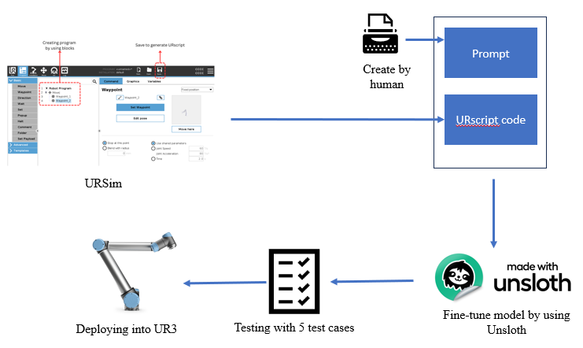

Figure 1.1. Workflow of project

To address these challenges, we propose fine-tuned model with high quality instruct tuning dataset, and evaluate its performance on a range of specific tasks, our contributes in this thesis is:

* **Data collection**: In this research, we collected a tailored dataset for fine-tuning our model by leveraging URsim [4], a simulation software designed for programming and testing Universal Robots. URsim provides a versatile environment for creating datasets by enabling the development of robot control scripts through component blocks, which simplify coding and enhance clarity. By utilizing these modular blocks, we efficiently simulated diverse robotic tasks and configurations, ensuring the dataset’s robustness and relevance to our target application. This approach not only streamlined data generation but also minimized potential errors, making it a reliable foundation for fine-tuning our model.
* **Fine-tune model**: To fine-tune our model, we employed the Unsloth framework, leveraging its advanced capabilities to refine multiple Qwen models, including Qwen-Base and Qwen-Coder in both 3B and 7B configurations. Using the dataset collected via URsim, we conducted supervised fine-tuning, enabling the models to adapt to task-specific patterns and complexities inherent in our data. This approach allowed for efficient optimization of both general language understanding (Qwen-Base) and specialized coding tasks (Qwen-Coder), ensuring the models could accurately interpret and execute robotic commands
* **Testing and deploying**: To validate our fine-tuned model, we conducted testing across five carefully selected use cases, each reflecting critical aspects of real-world robotic operations. These use cases included motion planning, object manipulation, error recovery, adaptive decision-making, and multi-step task execution. The performance of the model was first evaluated in a simulated environment using URsim to ensure alignment with the dataset used during fine-tuning. Subsequently, we deployed the code generated by the fine-tuned LLM directly onto a UR3 robotic arm, enabling us to assess its ability to perform physical tasks accurately and reliably

# LITERATURE REVIEW

## LLM

Large Language Models (LLMs) represent a significant milestone in artificial intelligence (AI), designed to understand and generate human-like text with remarkable accuracy. Built using advanced deep learning architectures, particularly transformer-based frameworks, these models leverage massive datasets that span diverse domains of human knowledge, including books, articles, and websites. Their capabilities have revolutionized natural language processing (NLP) tasks such as machine translation, summarization, and more sophisticated applications like code generation, creative writing, and conversational AI.

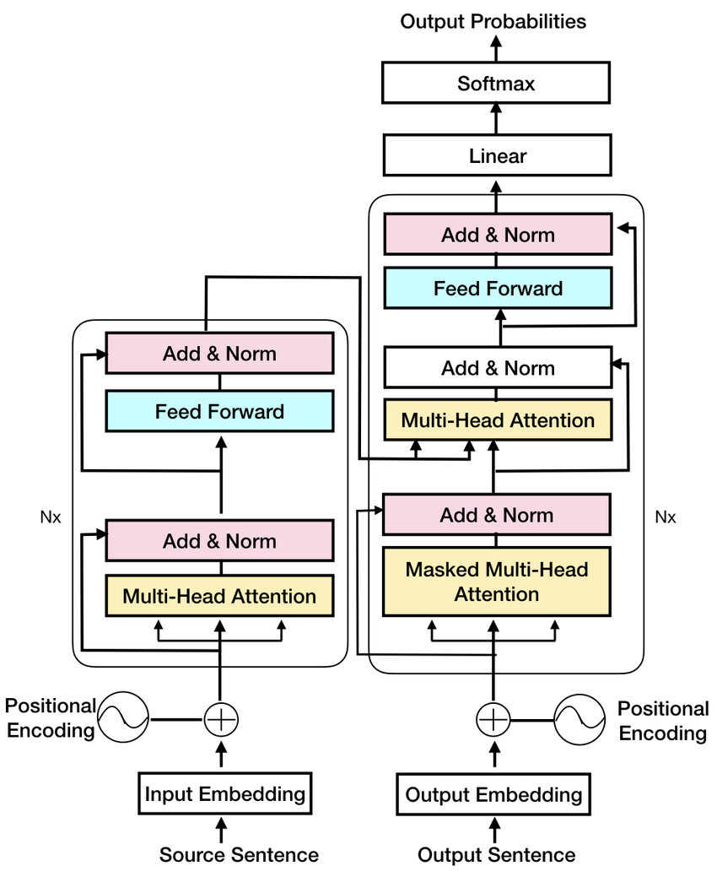

Figure 2.1. Transform architecture from paper **Attention Is All You Need**

At the core of LLMs lies the transformer architecture, introduced by Vaswani et al., which introduced a self-attention mechanism that efficiently models long-range dependencies in sequential data. The self-attention mechanism is mathematically expressed as:

$Attention\left(Q,K,V\right)=softmax\left(\frac{QK^{T}}{\sqrt{d_{k}}}\right)V$ (2.1)

Here, *Q, K*, and *V* represent the query, key, and value matrices, while $d_{k}$ ​ is the dimensionality of the keys. This mechanism allows LLMs to dynamically focus on relevant parts of the input sequence, capturing context effectively across large texts.

LLMs operate on the principle of pretraining and fine-tuning. In the pretraining phase, the model is optimized to minimize a loss function over a vast corpus of unstructured data. Typically, this involves a masked language modeling objective, such as:

$L_{MLM}=−\sum_{i=1}^{N}{logP\left(x_{i}∨x_{i}\right)}$ (2.2)

where $x_{i}$ ​ represents the current token and $x_{i}$ ​ denotes the sequence of preceding tokens. Fine-tuning adapts this pretrained model to specific downstream tasks, refining its parameters to optimize task-specific objectives, often using supervised learning.

The emergence of models like GPT, BERT, and GPT-3 reflects iterative advancements in both architecture and training methodologies, made possible by increased computational resources. For instance, GPT-3, a 175-billion parameter model, exemplifies the scalability of LLMs and their ability to generalize across diverse tasks without explicit retraining.

Despite their versatility, LLMs pose significant challenges. Ethical concerns include biases in training data, risks of misinformation, and the environmental costs associated with training large-scale models, which can be quantified by the computational energy required, $E∝n_{p}.n_{y}.n_{t}$ where $n_{p}$ is the number of parameters, the size of the dataset, and $n_{t}$ ​ the number of training iterations. Addressing these issues is a key focus in ongoing research.

Nonetheless, LLMs remain at the forefront of AI innovation, driving transformative advancements across industries while inspiring further exploration into optimizing their efficiency, fairness, and applicability.

## Qwen LLM models

The Qwen large language models (LLMs), developed by Alibaba Cloud, represent a significant advancement in the field of artificial intelligence. These transformer-based models, initially introduced with the Qwen1.8B and later scaled to the Qwen2 and Qwen2.5 series, have been optimized for various applications, including general purpose natural language understanding, multilingual processing, and domain specific tasks like coding and mathematical reasoning [11]. Qwen models leverage state-of-the-art innovations in transformer architectures, such as Rotary Positional Embeddings (RoPE) and Grouped Query Attention (GQA), to enhance performance and scalability. The Qwen2.5 series offers models with parameters ranging from 3 billion to 72 billion, enabling fine-tuning and instruction tuning for task-specific applications. Notably, the Qwen2.5-72B model achieves state of-the-art results in reasoning and multilingual understanding, comparable to leading models like GPT-4 and Llama2.

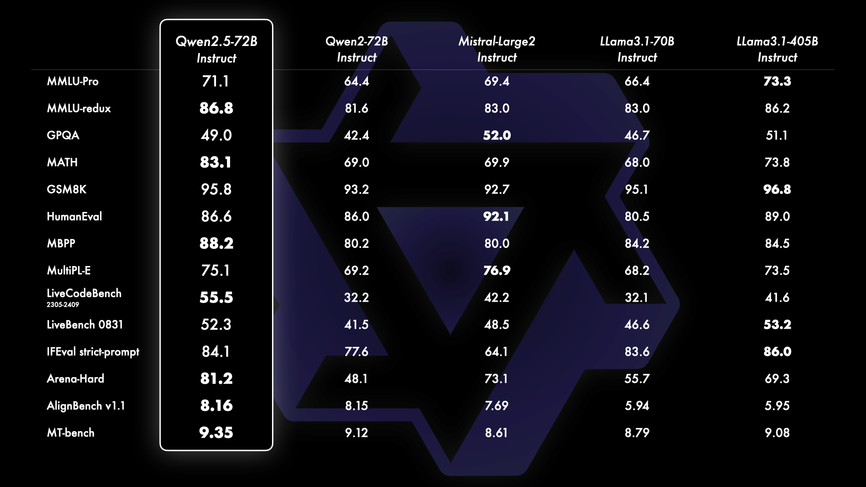

Figure 2.2. Benchmarking with leading open-source models like Llama-3.1-70B and Mistral-Large-V2

Figure 2.2 compares the performance of multiple instruction-tuned language models across various benchmarks. The models analyzed include Qwen2.5-7B, Qwen2-7B, MistralLarge-2, Llama3-7B, and Llama3-1405B, with scores provided for diverse tasks like MMLU, GSM8K, HumanEval, and MultiPL-E, among others. Notably, **Llama3-1405B Instruct** consistently achieves the highest scores across most metrics, such as an exceptional 96.8 in HumanEval and 86.2 in MMLUredux, demonstrating its strong general and domain-specific capabilities. Meanwhile, **Qwen2.5-7B Instruct** also performs competitively, particularly excelling in GSM8K (95.6) and MMLUredux (86.8), indicating its strength in reasoning and math-focused tasks despite having fewer parameters than the Llama3-1405B. Smaller models like Qwen2-7B and MistralLarge-2 offer balanced performance with good scores, reflecting efficiency in targeted tasks. This comparison highlights the trade-offs between parameter size and performance across different applications.

Pretraining for Qwen models involves processing trillions of tokens from diverse multilingual datasets, with particular emphasis on English and Chinese. Post-training employs techniques such as Supervised Fine-Tuning (SFT) and Reinforcement Learning with Human Feedback (RLHF) to refine model alignment and improve response quality. These methods ensure that Qwen models not only deliver accurate responses but also demonstrate creativity and adherence to user instructions. In addition to their general-purpose capabilities, specialized variants like Qwen2.5 Coder and Qwen2.5-Math are tailored for technical domains. Qwen2.5-Coder excels in programming tasks, such as debugging and code generation, while Qwen2.5-Math enhances mathematical reasoning using advanced techniques like Chain-of-Thought and Proof-of-Theorem reasoning. [12], [13]

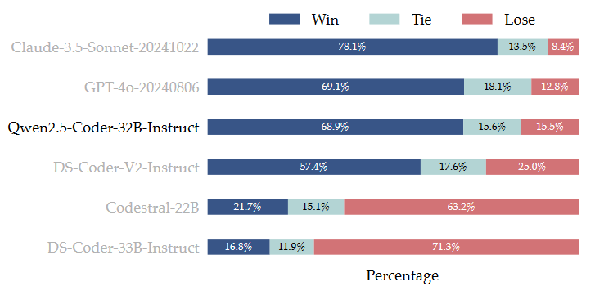

Figure 2.3. The CodeArena Performance of Qwen2.5-Coder-32B-Instruct compared with

popular open-source large code models with similar size

Figure 2.3 showing a chart compares the performance of several coding models—Claude-3.5-Sonnet-20241022, GPT-4o-20240806, Qwen2.5-Coder-32B-Instruct, DS-Coder-V2-Instruct, Codestral-22B, and DS-Coder-33B-Instruct—in terms of winning, tying, or losing against competitors. **Claude-3.5-Sonnet** achieves the best results, with an impressive **78.1% win rate**, the highest among all models, and only an **8.4% loss rate**, demonstrating exceptional coding performance. **GPT-4o** follows closely, with a **69.1% win rate**, slightly outperforming **Qwen2.5-Coder-32B-Instruct** (68.9%), which also has a competitive win rate and a balanced **15.5% loss rate**. **DS-Coder-V2-Instruct** shows decent performance, with a **57.4% win rate**, but a higher **25% loss rate**, indicating more frequent errors compared to the top-performing models. In contrast, **Codestral-22B** and **DS-Coder-33B-Instruct** significantly underperform, with win rates of **21.7%** and **16.8%**, respectively, and extremely high loss rates (**63.2%** and **71.3%**), suggesting limitations in their ability to compete effectively in coding benchmarks. This analysis highlights the dominance of larger, instruction-tuned models like Claude-3.5 and GPT-4o in coding tasks.

## Fine-tuning LLM models

Fine-tuning large language models (LLMs) is a process of adapting pre-trained models to specific tasks or domains by updating their parameters using a task-specific dataset. The core idea is to adjust the model’s weights W to minimize a loss function $L_{task}$ ​, calculated as:

$L_{task}=\frac{1}{N}\sum_{i=1}^{N}{l\left(f\left(x_{i};W\right),y_{i}\right)}$ (2.3)

where $x_{i}$ ​ represents the input data, $y_{i}$ ​ is the target output, and $l$ is a loss function, such as cross-entropy. The updated weights W′W'W′ are obtained using gradient descent:

$W^{'}=W−η∇L_{task}$ (2.4)

where η is the learning rate. However, fine-tuning all model parameters can be computationally expensive, especially for large models with billions of parameters.

To address this, techniques like **Low-Rank Adaptation (LoRA)** have been developed. LoRA introduces small, trainable low-rank matrices ΔW into the model, while keeping the original weights W frozen. For a weight matrix W, the modified forward pass becomes:

$W^{'}=W+∇W$ (2.5)

where ΔW=AB, and $A∈R^{dxr}$ and $B∈R^{rxd}$ and are low-rank matrices with $r≪d$. This significantly reduces the number of trainable parameters to $O\left(r.d\right)$, making fine-tuning more efficient while retaining performance. Fine-tuning with LoRA thus enables the adaptation of LLMs to specific tasks with reduced computational and memory overhead, broadening their applicability to resource-constrained settings.

## Universal Robot ecosystem

### URScript: Flexible Robotic Programming Language

URScript is a high-level scripting language specifically developed by Universal Robots to program and control its robotic arms. It provides functionality beyond the graphical PolyScope interface, allowing users to write customized scripts for intricate control over robot movements, logical operations, and system interactions. Through URScript, developers can integrate external equipment, implement socket communications, and control robots in real time [14].

**Examples of URscript:**

def move_joint():

local Waypoint_1_p=p[-0.13, -0.26, 0.14, -0.001, 3.11, 0.03]

local Waypoint_1_q=[-1.6, -1.72, -2.2, -0.8, 1.59, -0.03] # radian

local Waypoint_2_p=p[-0.008, -0.26, 0.28, -0.27, -2.71, 0.217]

local Waypoint_2_q=[-0.92, -1.26, -1.88, -1.73, 1.16, 0.88] # radian

while (True):

movej(get_inverse_kin(

Waypoint_1_p, qnear=Waypoint_1_q), a=1.39, v=1.04)

movej(get_inverse_kin(

Waypoint_2_p, qnear=Waypoint_2_q), a=0.78, v=0.87)

end

end

URScript’s design makes it accessible for diverse user expertise levels, enabling its adoption in complex industrial tasks and academic experiments alike. Key features of URScript include:

* Multi-threading: Manage simultaneous tasks, crucial for real-time robotic operations.
* Conditional Logic and Loops: Facilitate advanced automation scenarios.
* Integration Capabilities: Support for external devices and communication protocols.

### URSim: Virtual Robotic Simulation Platform

URSim is a simulation environment provided by Universal Robots for offline programming. It replicates the functionality of physical cobots, allowing users to develop and test URScript programs without hardware access. By supporting virtual testing, URSim accelerates development cycles, reduces operational risks, and facilitates educational use cases. [15], [16]

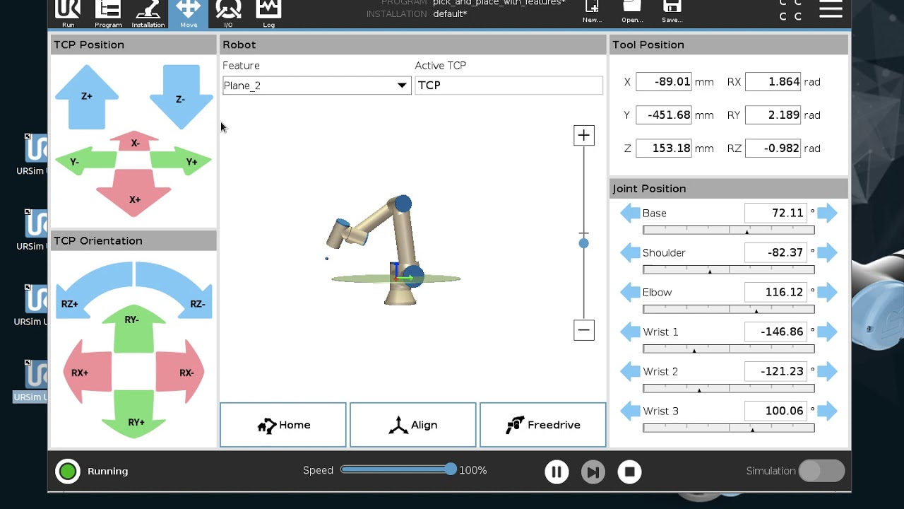

Figure 2.1. GUI of URSim

Core aspects of URSim include:

• Realistic Robot Simulation: Mimics robot behaviors, including motion planning and I/O signal testing.

• Cross-Platform Compatibility: Operates through virtual machines, supporting Linux and non-Linux systems.

• Seamless Integration with URScript: Provides a direct bridge to physical robots, enabling users to transfer programs efficiently from virtual environments.

## UR robots

### UR3

The UR3 collaborative robot (cobot), developed by Universal Robots, is a lightweight, six-axis robotic arm designed for tabletop automation. This compact cobot is particularly suitable for precision tasks in confined workspaces, offering a payload capacity of 3 kg, a reach of 500 mm, and repeatability of ±0.1 mm. Weighing only 11 kg, the UR3 is easy to deploy and integrate into diverse manufacturing and research environments. [17]

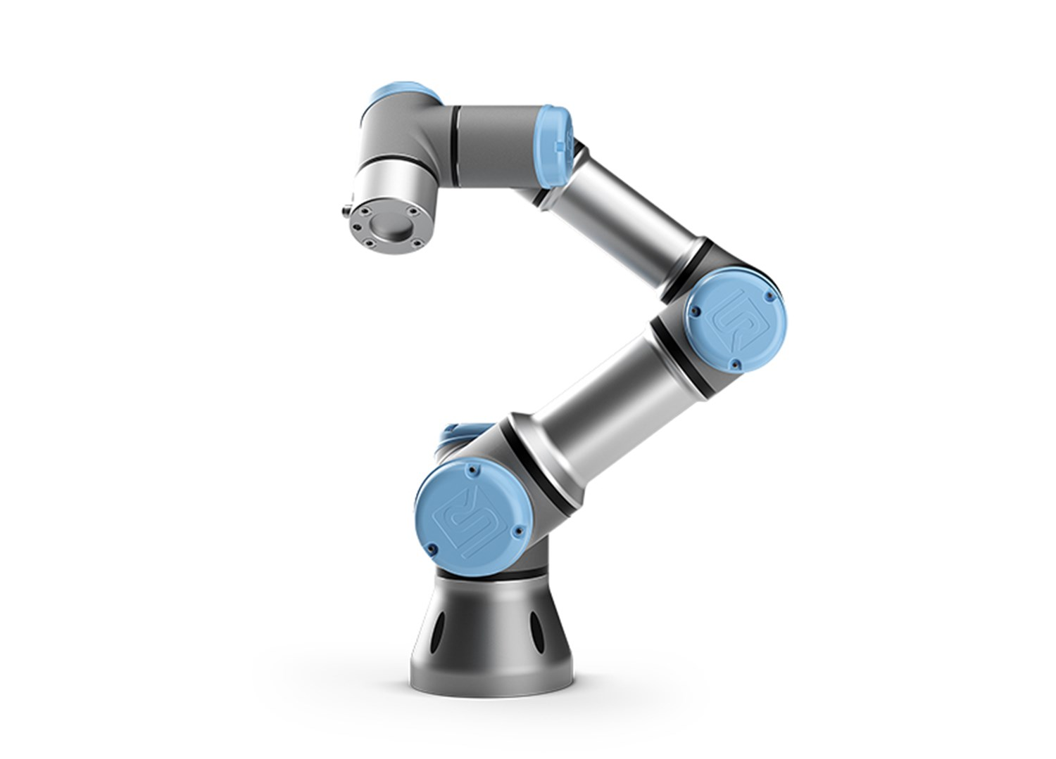

Figure 2.2. Illustration by UR3

The UR3 exemplifies the growing trend of collaborative robotics, where flexibility, ease of use, and safety redefine industrial and research workflows. By minimizing setup time and maximizing productivity, the UR3 enables small and medium enterprises to leverage automation effectively. It is also a valuable tool in research settings, facilitating experimentation and automation of repetitive tasks.

### UR remote control via TCP

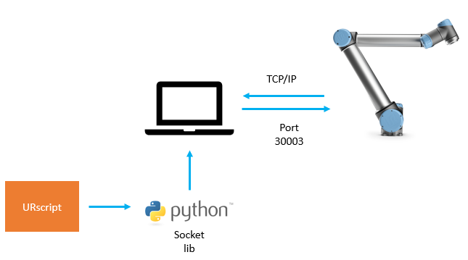

Figure 2.3. UR remote control using TCP/IP

To facilitate the remote control of Universal Robots (UR) in this study, the methodology involves sending URScript commands via TCP/IP sockets. This approach enables dynamic robot programming and task execution directly from an external computer. The steps employed are outlined below:

1. Establishing a TCP Connection

The robot controller provides network interfaces for remote communication. A TCP socket is created to connect to the robot's IP address and designated port (e.g., 30002 for secondary client or 30003 for real-time client). This connection acts as a communication channel for sending commands in URScript format.

1. Sending URScript Commands

URScript, the proprietary scripting language for UR robots, is used to define robot operations such as motion control and I/O management. Each command is formatted as a string and transmitted through the established socket. The commands must adhere to URScript syntax and conclude with a newline character (\n) to indicate their termination. An example command is:

```URscript

movej([0, -1.57, 0, -1.57, 0, 0], a=1.2, v=0.25)

```

The Python programming language was chosen for socket implementation due to its simplicity and versatility. The following code snippet illustrates the process:

```Python

import socket

# Define robot's IP address and port

HOST = "192.168.1.2" # Replace with actual robot IP

PORT = 30002

# Create and connect the socket

s = socket.socket(socket.AF_INET, socket.SOCK_STREAM)

s.connect((HOST, PORT))

# Send the URScript command

command = "movej([0, -1.57, 0, -1.57, 0, 0], a=1.2, v=0.25)\n"

s.send(command.encode('utf-8'))

# Close the connection

s.close()

```

# METHODOLOGY

## Data collection

To gather high-quality datasets, we leverage URSim as a simulation platform to streamline the development of control programs written in URScript. This approach ensures that the generated code is syntactically correct, logically coherent, and adheres to predefined safety standards. By using URSim, developers can simulate and validate robotic operations in a virtual environment, minimizing errors and enhancing the reliability of control programs before deploying them on physical robots. This methodology not only improves operational safety but also accelerates the iterative development process by allowing safe testing of complex logic and configurations. In Figure 3, during dataset creation, we can execute the control code and observe the movements of the simulated robot provided by URSim. Simultaneously, we can verify the proper functioning of the I/O modules to ensure their statuses align with the expected outcomes. This process allows for real-time validation of both robot behavior and system integration.

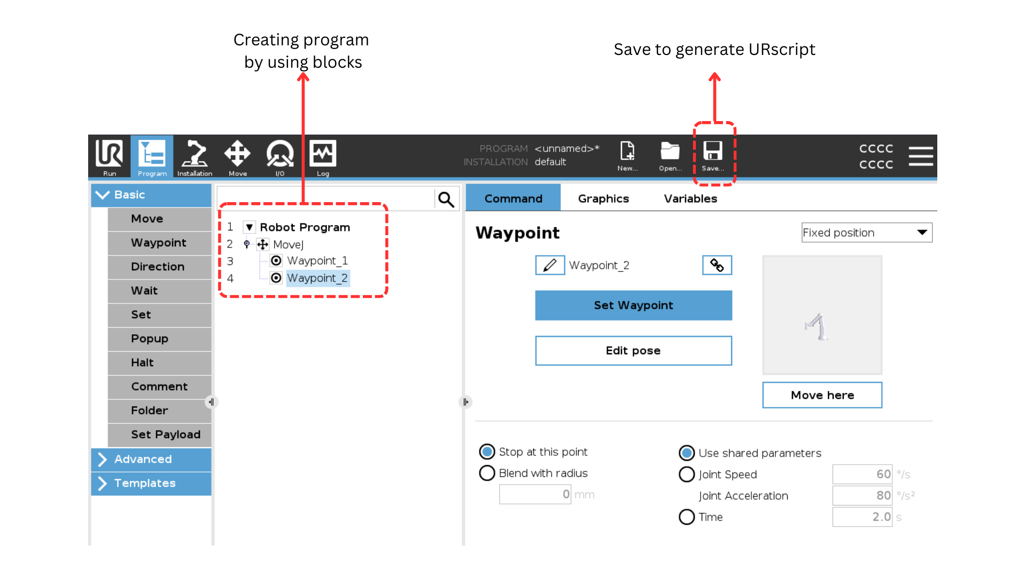

Figure 3.1. Generate URscript code by using URSim

After gathering the URScript code snippets, we developed a set of instructions derived from these snippets. Our approach incorporated both concise descriptions and more detailed explanations of the associated problems, aiming to evaluate the effectiveness of fine-tuning the model. Here is a sample of it, including shorter and longer version of instruction:

First Instruction:

Define a URscript function can move UR robot between 2 waypoints in joint-space given tool position and joint position of waypoint_1 are [-0.13,-0.26, 0.14, -0.001, 3.11, 0.03] and [-1.6, -1.72, -2.2, -0.8, 1.59, -0.03], tool position and joint position of waypoint_2 are [-0.008, -0.26, 0.28, -0.27, -2.71, 0.217] and [-0.92, -1.26, -1.88, -1.73, 1.16, 0.88], joint acceleration and joint speed are 1.39 radian/s^2 and 1.04 radian/s with waypoint_1, 0.78 radian/s^2 and 0.87 radian/s with waypoint_2, we use active TCP

Second Instruction:

Define a URscript function can move UR robot between 2 waypoints in joint-space given tool and joint position, and use active TCP

For the output (code snippets), we enhanced the content by incorporating human written instructions and adding an explanatory section to clarify the code. This approach is intended to assist the LLM model in establishing stronger associations, retaining critical keywords, and improving its logical reasoning for generating URScript code:

Here's a function in URscript that allow you to move UR robot between 2 waypoints in joint-space given tool position and joint position, using active TCP:

```URscript

def move_joint():

local Waypoint_1_p=p[-0.13, -0.26, 0.14, -0.001, 3.11, 0.03]

local Waypoint_1_q=[-1.6, -1.72, -2.2, -0.8, 1.59, -0.03] # radian

local Waypoint_2_p=p[-0.008, -0.26, 0.28, -0.27, -2.71, 0.217]

local Waypoint_2_q=[-0.92, -1.26, -1.88, -1.73, 1.16, 0.88] # radian

while (True):

movej(get_inverse_kin(

Waypoint_1_p, qnear=Waypoint_1_q), a=1.39, v=1.04)

movej(get_inverse_kin(

Waypoint_2_p, qnear=Waypoint_2_q), a=0.78, v=0.87)

end

end

```

### Explaination:

1. `Waypoint_1_p`: tool position or pose (x, y, x, Rx, Ry, Rz) of waypoint_1

2. `Waypoint_1_q`: joint position (Base, Shoulder, Elbow, Wrist 1, Wrist 2) of waypoint_1

3. `Waypoint_2_p`: tool position (x, y, x, Rx, Ry, Rz) of waypoint_2

4. `Waypoint_2_q`: joint position (Base, Shoulder, Elbow, Wrist 1, Wrist 2, Wrist 3) of waypoint_2

5. `movej()`: command move robot to position in joint-space, given joint acceleration(a) and joint speed(v)

6. `get_inverse_kin()`: calculate the inverse kinematic transformation ( from tool space to joint space)

You can modify the necessary parameters such as joint positions, tool positions, or the velocity and acceleration of the movej() function.

## Fine-tune model

The Qwen model was chosen for this research due to its outstanding performance and extensive support for diverse applications, making it a suitable candidate for URScript code generation tasks. As a state-of-the-art language model, Qwen demonstrates strong capabilities in understanding and generating complex text structures, including programming languages, thanks to its advanced transformer architecture and large-scale pretraining. Furthermore, the availability of multiple parameter sizes, such as 3B and 7B, allows for a balance between computational efficiency and performance, enabling scalability based on resource constraints. Qwen’s robust community support, frequent updates, and seamless integration with frameworks like Hugging Face Transformers ensure that it remains a versatile and reliable tool for fine-tuning in specialized domains. These factors collectively position Qwen as an optimal choice for enhancing the logical accuracy and contextual relevance required for generating URScript code.



Figure 3.2. Unsloth framework: LLMs 2-5x faster with 80% less memory

To enhance the capabilities of the Qwen-3B and Qwen-7B models for generating URScript code, we employed the Unsloth framework, a lightweight yet powerful f ine-tuning approach designed for domain-specific applications. Unsloth facilitates efficient adaptation of large-scale language models by integrating optimized training workflows, flexible configuration options, and robust evaluation techniques. This section outlines the process of fine-tuning the Qwen models, leveraging Unsloth to maximize model performance and computational efficiency.

Table 3.1 . Params setting for fine-tune wit Unsloth framework

|  |  |
| --- | --- |
| Params | Value |
| max_seq_length | 2048 |
| load_4_bit | True |
| r | 16 |
| lora_alpha | 16 |
| lora_dropout | 0 |
| target_modules | ['q_proj', 'k_proj', 'v_proj', 'o_proj', 'gate_proj', 'up_proj', 'down_proj'] |
| max_steps | 60 |
| learning_rate | 2e-4 |
| optim | admw_8bit |
| weight_decay | 0.01 |
| lr_sheduler_type | linear |

The decision to use the Qwen-3B and Qwen-7B models for this research was driven by the computational resources available, specifically the T4 GPU provided by **Google Colab**. These models strike a practical balance between performance and resource demands, making them well-suited for fine-tuning and experimentation within the constraints of a single-GPU environment. The T4 GPU, with its 16 GB of VRAM, is capable of handling the memory requirements of the 3B model efficiently and supports the 7B model with optimized batching and mixed-precision training techniques. This setup ensures that the research can be conducted without requiring expensive high-performance hardware, while still leveraging state-of-the-art models to achieve meaningful results in URScript code generation tasks.

## Testing

After fine-tuning the Qwen models for URScript code generation, we evaluated their performance through real-world testing scenarios to assess their practical utility. This involved providing the fine-tuned models with real-world task descriptions derived from industrial automation settings and generating corresponding URScript code. The generated code was then deployed on Universal Robots to execute tasks such as pick-and-place operations, movement sequences, and sensor integration. The outcomes were assessed based on execution accuracy, logical consistency, and adherence to URScript syntax and conventions. Feedback from domain experts was also incorporated to evaluate the models’ ability to handle ambiguous or complex task descriptions. This real-world testing not only validated the practical effectiveness of the fine-tuned models but also identified areas for further optimization, such as improving robustness in handling edge cases and enhancing contextual understanding for dynamic tasks.

In this study, testing was conducted by defining five progressively complex problems and comparing the code generated by the fine-tuned model with code written by human experts. This approach allowed for a detailed evaluation of the model’s performance in terms of accuracy, logical consistency, and alignment with human crafted solutions across varying levels of problem difficulty.

The first test case involves a straightforward task, where the robot moves from an initial position to a target position. In the second test case, the complexity increases as the control process requires the robot to navigate through multiple waypoints.

|  |  |  |  |
| --- | --- | --- | --- |
|  | **Instruction** | **Target Output** | **Validity** |
| Test case 1 | Instruction: Define a URscript function can move UR robot between 2 waypoints linear in tool-space given tool position and joint position of waypoint_1 are [1, 1, 1, 1, 1, 1] and [-1.6, -1.72, -2.2, -0.8, 1.59, -0.03], tool position and joint position of waypoint_2 are [-0.008, -0.26, 0.28, -0.27, -2.71, 0.217] and [-0.92, -1.26, -1.88, -1.73, 1.16, 0.88], joint acceleration and joint speed are 1.39 radian/s^2 and 1.04 radian/s with waypoint_1, 0.78 radian/s^2 and 0.87 radian/s with waypoint_2, we use active TCP | def move_joint():  local Waypoint_1_p=p[-0.13, -0.26, 0.14,  -0.001, 3.11, 0.03]  local Waypoint_1_q=[-1.6, -1.72, -2.2,  -0.8, 1.59, -0.03] # radian  local Waypoint_2_p=p[-0.008, -0.26, 0.28,  -0.27, -2.71, 0.217]  local Waypoint_2_q=[-0.92, -1.26, -1.88,  -1.73, 1.16, 0.88] # radian  while (True):  movej(get_inverse_kin(  Waypoint_1_p, qnear=Waypoint_1_q), a=1.39, v=1.04)  movej(get_inverse_kin(  Waypoint_2_p, qnear=Waypoint_2_q), a=0.78, v=0.87)  end  end |  |

### Test case 1

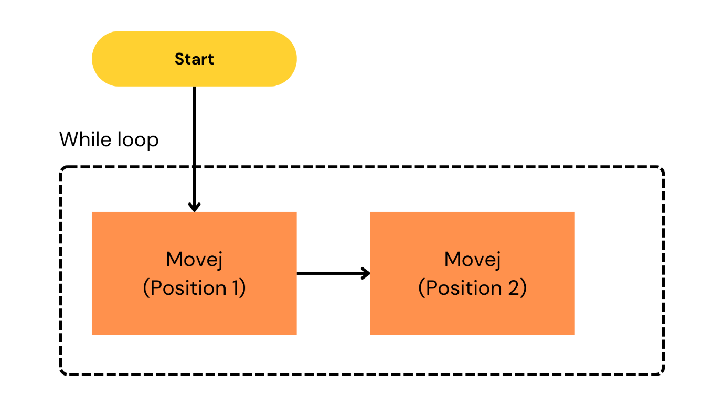

Figure 3.3. Diagram of first test case

# Task 1: Move between 2 waypoint

def move_joint():

local Waypoint_1_p=p[-0.13, -0.26, 0.14, -0.001, 3.11, 0.03]

local Waypoint_1_q=[-1.6, -1.72, -2.2, -0.8, 1.59, -0.03] # radian

local Waypoint_2_p=p[-0.008, -0.26, 0.28, -0.27, -2.71, 0.217]

local Waypoint_2_q=[-0.92, -1.26, -1.88,

-1.73, 1.16, 0.88] # radian

while (True):

movej(get_inverse_kin(

Waypoint_1_p, qnear=Waypoint_1_q), a=1.39, v=1.04)

movej(get_inverse_kin(

Waypoint_2_p, qnear=Waypoint_2_q), a=0.78, v=0.87)

end

end

move_joint()

### Test case 2

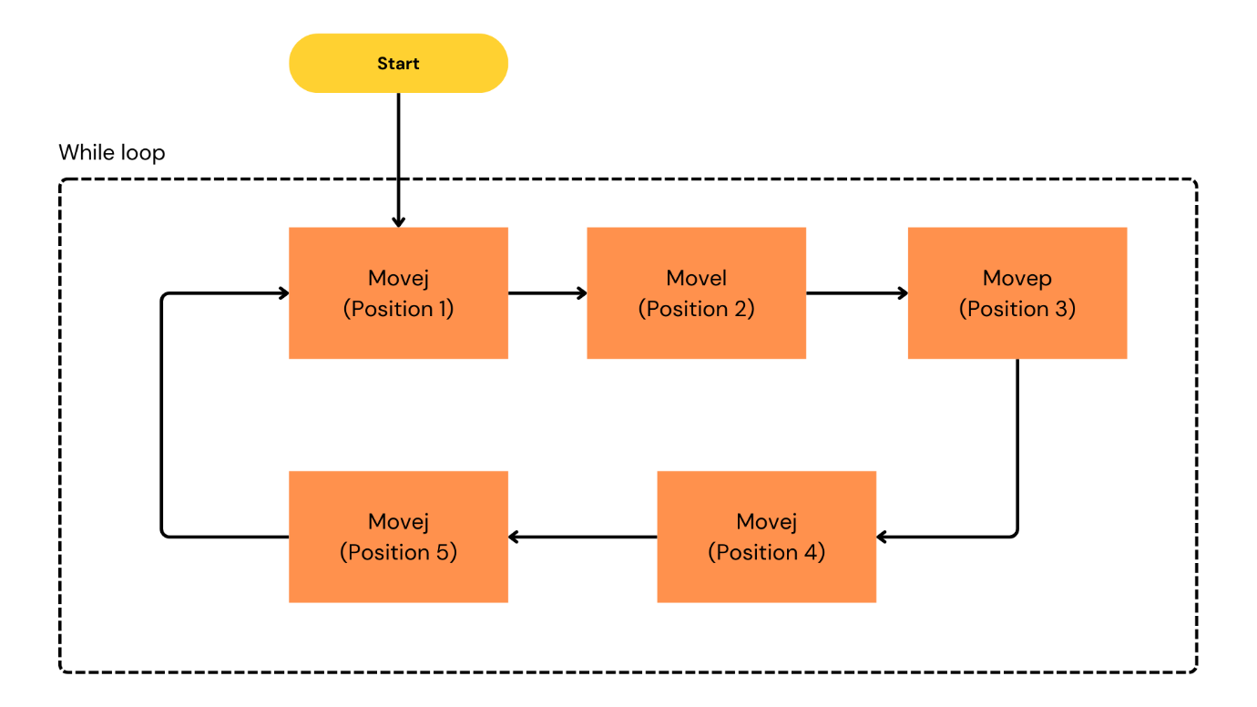

Figure 3.3. Diagram of second test case

# Task 2: Move Through a Series of Waypoints

def move_series():

local Waypoint_1_p=p[-0.13, -0.26, 0.14, -0.001, 3.11, 0.03]

local Waypoint_1_q=[-1.6, -1.72, -2.2, -0.8, 1.59, -0.03]

local Waypoint_2_p=p[-0.08, -0.2, 0.21, -0.001, 3.11, 0.03]

local Waypoint_2_q=[-1.35, -1.15, -2.3, -1.27, 1.6, 0.21]

local Waypoint_3_p=p[0.05, -0.27, 0.28, -0.001, 3.11, 0.03]

local Waypoint_3_q=[-0.89, -1.37, -1.8, -1.53, 1.6, 0.67]

local Waypoint_4_p=p[0.05, -0.27, 0.38, -0.00, 3.11, 0.03]

local Waypoint_4_q=[-0.89, -1.44, -1.3, -1.96, 1.6, 0.67]

local Waypoint_5_p=p[0.05, -0.27, 0.09, -0.001, 3.11, 0.03]

local Waypoint_5_q=[-0.89, -1.91, -2.39, -0.41, 1.6, 0.67]

while (True):

movej(get_inverse_kin(Waypoint_1_p, qnear=Waypoint_1_q), a=1.39, v=1.04)

movel(Waypoint_2_p, a=1.0, v=0.15)

movep(Waypoint_3_p, a=1.2, v=0.25, r=0.0)

movej(get_inverse_kin(Waypoint_4_p, qnear=Waypoint_4_q), a=1.39, v=1.04)

movej(get_inverse_kin(Waypoint_5_p, qnear=Waypoint_5_q), a=1.39, v=1.04)

end

end

move_series()

For the third test case, the problem requires more about system control and interaction with I/O, here applied to the simple problem of picking up and releasing objects. In Figure 7, when starting the process, the robot will move to the position where it needs to pick up the object, then need to set the corresponding I/O pin to perform the picking operation, then move to the predetermined location. to release the hand by setting the I/O pin, finally the robot moves back to its original position.

### Test case 3

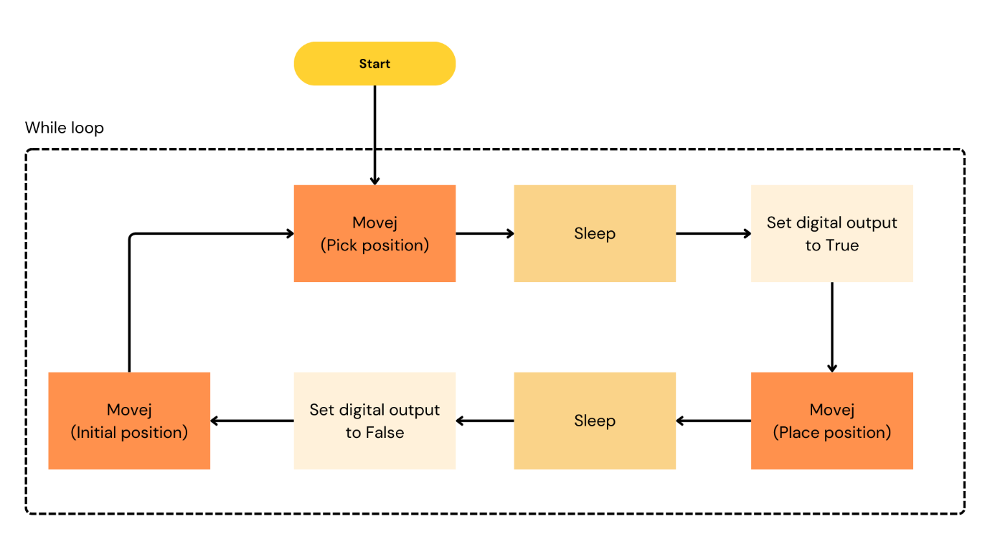

Figure 3.4. Diagram of third test case

# Task 3: Pick and Place Operation

def pick_and_place():

local pick_position = [0.2, -1.2, 1.0, 0.0, 1.57, 0.0] # Position above the object

local place_position = [0.5, -1.2, 1.0, 0.0, 1.57, 0.0] # Position above the target

while (True):

movej(pick_position, a=1.2, v=0.25) sleep(0.5) # Simulate closing the gripper (assuming Digital Output 0 controls gripper)

set_digital_out(0, True)

sleep(0.5) # Pause for grip to engage

# Lift the object

movej([0.2, -1.0, 1.0, 0.0, 1.57, 0.0], a=1.2, v=0.25)

# Move up slightly # Move to place position

movej(place_position, a=1.2, v=0.25)

sleep(0.5)

# Release the object

set_digital_out(0, False)

sleep(0.5) # Pause for release

# Return to initial position

movej([0, -1.57, 1.57, 0.0, 1.57, 0.0], a=1.2, v=0.25)

end

end

pick_and_place()

### Test case 4

Regarding the 4th test case, the task will be a little different as it requires more expressions, ensuring safety for the robot UR. At the beginning of the cycle, the robot will move to the initial position before testing. check whether it is in a safe location or not, if not, the program will create a popup warning the user and interrupt the program. If the move is safe, the check will proceed to the next point or point. destination, if there are still guarantees of safety, UR robot will return to its original position in a new process.

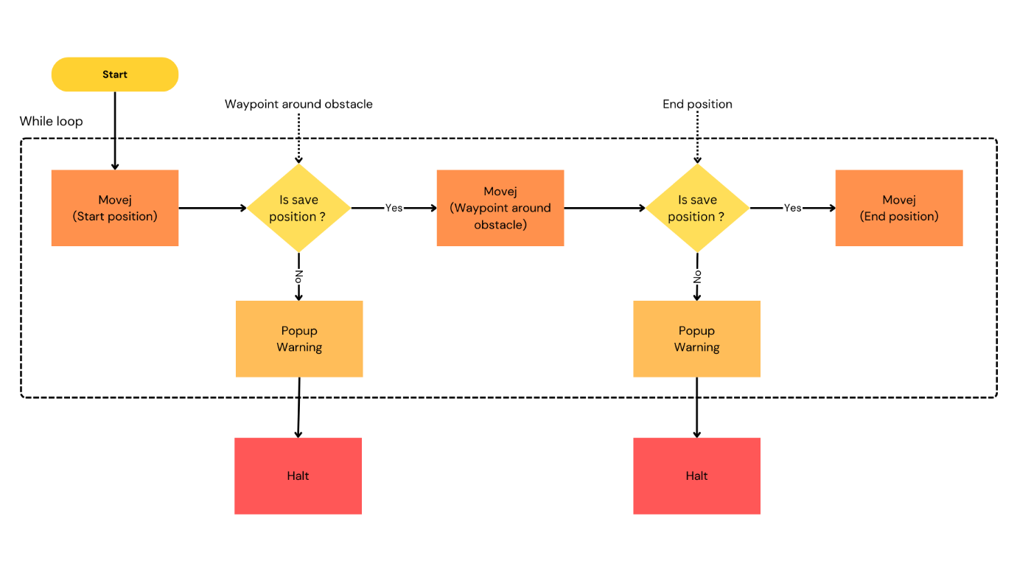

Figure 3.5. Diagram of fourth test case

# Task 4: Avoid Obstacles During Motion

def avoid_obstacles():

local start_position = [0.0, -1.57, 1.57, 0.0, 1.57, 0.0]

local waypoint_around_obstacle = [0.4, -1.2, 1.2, -0.3, 1.3, 0.2]

local end_position = [0.6, -1.2, 1.2, 0.0, 1.57, 0.0]

while (True): # Check if path is safe (mock safety check)

def is_safe_position(pos):

if pos[0] > 0.5:

popup('Warning: Path is restricted!', warning=True)

return False

else:

return True

end

end

movej(start_position, a=1.2, v=0.25)

if is_safe_position(waypoint_around_obstacle):

movej(waypoint_around_obstacle, a=1.2, v=0.25)

else:

popup('Cannot proceed to waypoint, obstacle detected!', warning=True)

halt

end

if is_safe_position(end_position):

movej(end_position, a=1.2, v=0.25)

else:

popup('Cannot reach destination, obstacle in path!', warning=True)

halt

end

end

avoid_obstacles()

The last task uses a separate thread to check the safety of the robot’s movement, applied to the simple problem of moving from point A to point B, a separate thread will continuously update the robot’s position. TCP is intended to determine whether security is violated or not. If so, the program will be interrupted and a popup will appear to let the user know.

### Test case 5

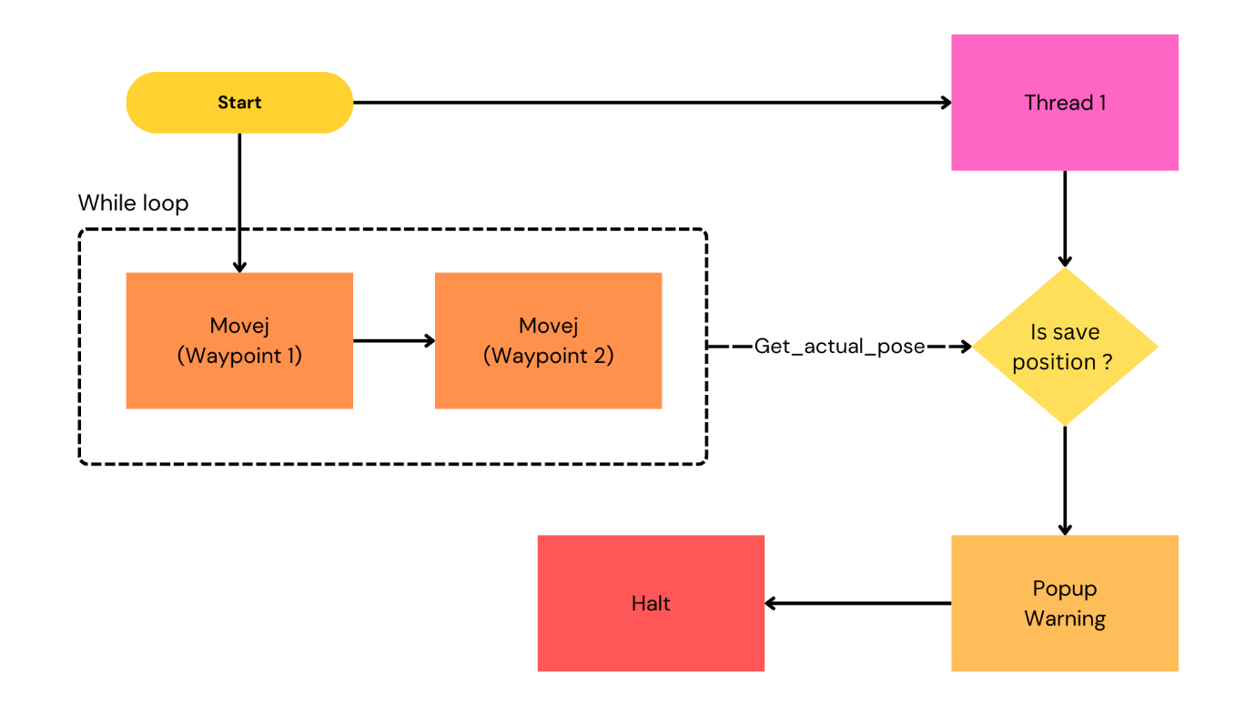

Figure 3.6. Diagram of fourth test case

# Task 5: Safety movement

def safety():

global Waypoint_1_p=p[-0.13, -0.33, 0.25, -0.001, 3.11, 0.03]

global Waypoint_1_q=[-1.59, -1.77, -1.56, -1.39, 1.59, -0.02]

global Waypoint_2_p=p[0.13, -0.33, 0.24, -0.001, 3.11, 0.03]

global Waypoint_2_q=[-0.82, -1.75, -1.61, -1.33, 1.6, 0.74]

thread Thread_1():

while (True):

global var_1= get_actual_tcp_pose ()

if (var_1[0]>0.1):

popup(str_cat('',var_1), 'Message', False, False, blocking=False)

halt

end

end

end

threadId_Thread_1 = run Thread_1()

while (True):

movej(get_inverse_kin(Waypoint_1_p, qnear=Waypoint_1_q), a=1.39, v=1.04)

movej(get_inverse_kin(Waypoint_2_p, qnear=Waypoint_2_q), a=1.39, v=1.04)

end

end

safety()

# EXPERIMENTAL RESULTS

Evaluating the fine-tuning effectiveness of large language models (LLMs) in a narrow domain like controlling robots with URScript is challenging due to the specificity of the tasks. This research focuses on developing evaluation parameters for the fine tuning process and optimizing the workflows for pre-defined tasks. The goal is to enhance the adaptability and precision of LLMs in this specialized application.

## Setup

For fine-tuning, we used the LoRA technique and 4-bit quantization model for less memory. For LoRA, we tried some parameter recommended by the original paper when set the lora_alpha to 16, set dropout to 0. With rank of this algorithm, we choose 16, and learning rate we set it to 2e-4, this learning rate is commonly used for f ine-tuning LLM and enables stable and incremental updates to the model’s parameters throughout the training process. For optimizer, “admw_8bit” (AdamW optimizer that employs 8-bit precision) is selected for fine-tune, combine with weight decay is 0.01. The fine-tuning experiments were conducted on Google Colab T4 GPU with consistent settings across all datasets.

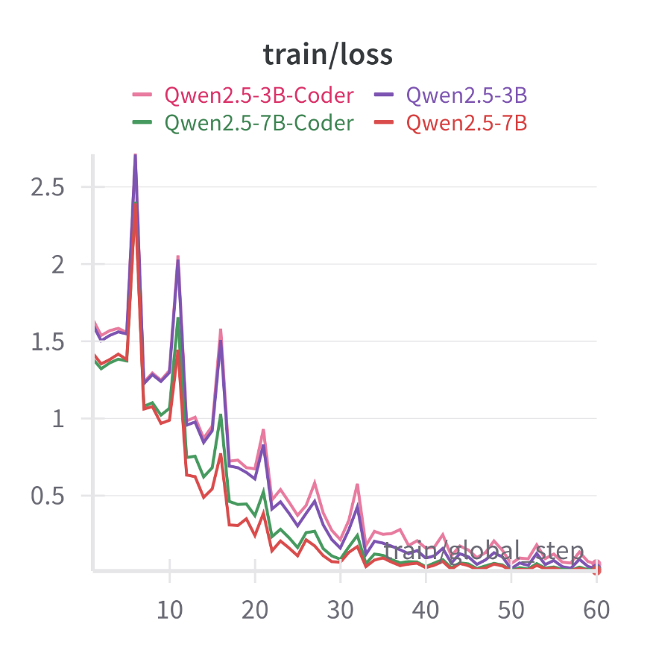

Figure 4.1. Loss of fine-tuning Qwen models.

## Results of fine-tuning

Figure 10 and 11 is fine-tuning result using Unsloth framework when apply with Qwen-Coder and Qwen-Base. However, fine-tuning the model across all four LLMs demonstrates consistent performance, as indicated by comparable loss parameters and gradient norms, suggesting no significant issues in the fine-tuning process itself. LLM evaluation becomes challenging in the absence of high-quality, domain-specific datasets.

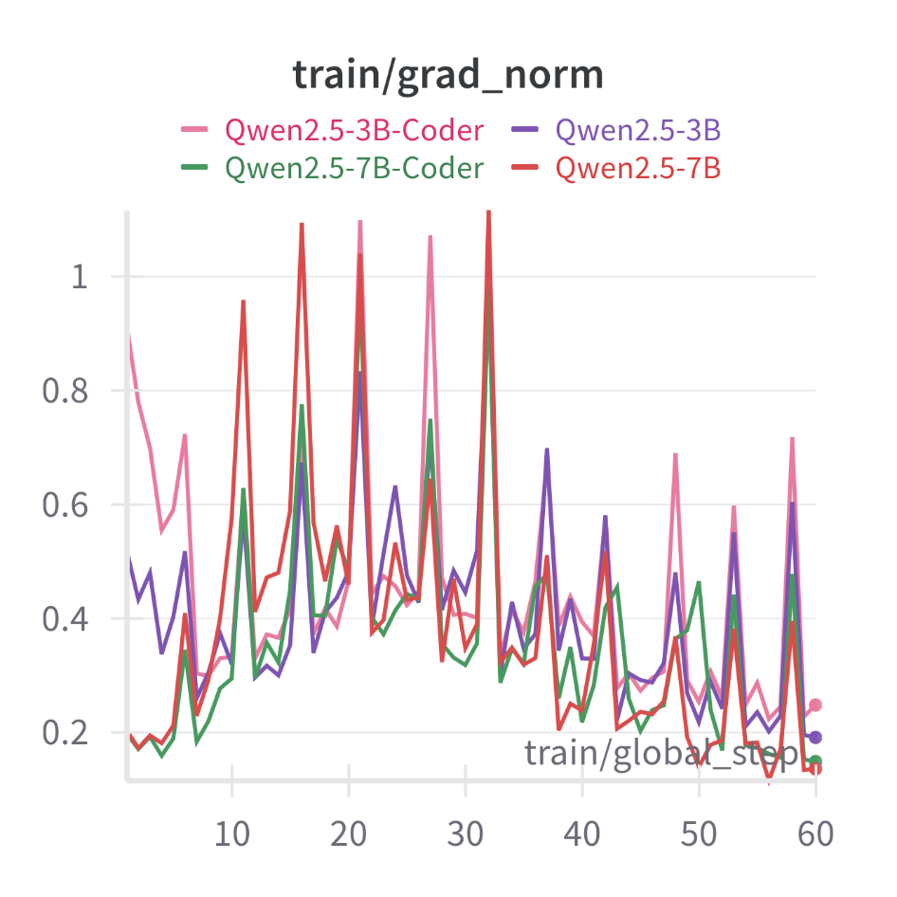

Figure 4.2. Grad norm of fine-tuning models.

The results, as summarized in Table 3, show a clear variation in performance across the models. Qwen2.5-Coder-7B demonstrated the highest logical understanding, successfully passing Tests 1, 2, and 3, while failing Tests 4 and 5. Qwen2.5-7B also performed well, passing Tests 1, 2, and 3, but its logical comprehension seemed slightly less robust, as indicated by its inconsistent reasoning in the more advanced tests. The smaller models, Qwen2.5-Coder-3B and Qwen2.5-3B, struggled with the logical complexity of the tasks, only managing to pass Test 1 and Test 2 while failing the remaining tests. It is worth noting that although lightweight models such as Qwen-Coder-3B and Qwen-3B do not perform as well, they still show some potential when try to apply it . The next step of project could be create more quality dataset by apply some state of the art methods.

## Result of Prompting

This section highlights the differences between fine-tuned models, such as Qwen-7B, Qwen-7B-Coder, Qwen-3B, and Qwen-3B-Coder, and non-fine-tuned models (Qwen-7B for) when applied to code generation for solving problems. The comparison is based on the results from five test cases created in the previous sections.

Table 4.1. Fine-tune models with test cases

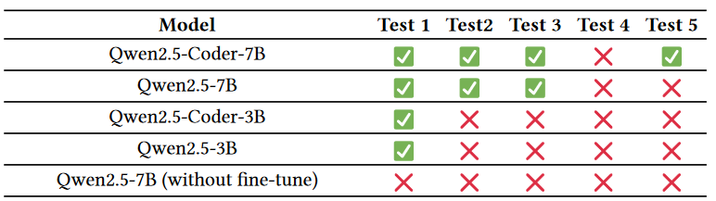

### 4.3.1. Test case 1

***Prompt***: Define a URscript function can move UR robot between 2 waypoints linear in tool-space given tool position and joint position of waypoint_1 are [1, 1, 1, 1, 1, 1] and [-1.6, -1.72, -2.2, -0.8, 1.59, -0.03], tool position and joint position of waypoint_2 are [-0.008, -0.26, 0.28, -0.27, -2.71, 0.217] and [-0.92, -1.26, -1.88, -1.73, 1.16, 0.88], joint acceleration and joint speed are 1.39 radian/s^2 and 1.04 radian/s with waypoint_1, 0.78 radian/s^2 and 0.87 radian/s with waypoint_2, we use active TCP

***Qwen-7B output*:**

Here's a function in URscript that allow you to move UR robot between 2 waypoints in joint-space given tool position and joint position, using active TCP:

```URscript

def move_joint():

local Waypoint_1_p=p[-0.13, -0.26, 0.14, -0.001, 3.11, 0.03]

local Waypoint_1_q=[-1.6, -1.72, -2.2, -0.8, 1.59, -0.03] # radian

local Waypoint_2_p=p[-0.008, -0.26, 0.28, -0.27, -2.71, 0.217]

local Waypoint_2_q=[-0.92, -1.26, -1.88, -1.73, 1.16, 0.88] # radian

while (True):

movej(get_inverse_kin(Waypoint_1_p, qnear=Waypoint_1_q), a=1.39, v=1.04)

movej(get_inverse_kin(Waypoint_2_p, qnear=Waypoint_2_q), a=0.78, v=0.87)

end

end

```

### Explaination:

1. `Waypoint_1_p`: tool position or pose (x, y, x, Rx, Ry, Rz) of waypoint_1

2. `Waypoint_1_q`: joint position (Base, Shoulder, Elbow, Wrist 1, Wrist 2) of waypoint_1

3. `Waypoint_2_p`: tool position (x, y, x, Rx, Ry, Rz) of waypoint_2

4. `Waypoint_2_q`: joint position (Base, Shoulder, Elbow, Wrist 1, Wrist 2) of waypoint_2

5. `movej()`: command move robot to position in joint-space, given joint acceleration(a) and joint speed(v)

6. `get_inverse_kin()`: calculate the inverse kinematic transformation (tool space > joint space)

You can modify the necessary parameters such as joint positions, tool positions, or the velocity and acceleration of the movej() function.

***Qwen-7B-Coder output*:**

Here's a function in URscript that allow you to move UR robot between 2 waypoints in joint-space given tool position and joint position, using active TCP:

```URscript

def move_linear():

local Waypoint_1_p=p[-0.13, -0.24, 0.14, -0.001, 3.11, 0.03]

local Waypoint_1_q=[-1.6, -1.72, -2.2, -0.8, 1.59, -0.03] # radian

local Waypoint_2_p=p[-0.008, -0.26, 0.28, -0.27, -2.71, 0.217]

local Waypoint_2_q=[-0.92, -1.26, -1.88, -1.73, 1.16, 0.88] # radian

while (True):

movep(Waypoint_1_p, a=1.39, v=1.04, r=0.025, qnear=Waypoint_1_q)

movep(Waypoint_2_p, a=0.78, v=0.87, r=0.025, qnear=Waypoint_2_q)

end

end

```

### Explaination:

1. `Waypoint_1_p`: tool position or pose (x, y, x, Rx, Ry, Rz) of waypoint_1

2. `Waypoint_1_q`: joint position (Base, Shoulder, Elbow, Wrist 1, Wrist 2) of waypoint_1

3. `Waypoint_2_p`: tool position (x, y, x, Rx, Ry, Rz) of waypoint_2

4. `Waypoint_2_q`: joint position (Base, Shoulder, Elbow, Wrist 1, Wrist 2) of waypoint_2

5. `movep()`: move robot to position, blend radius, time to make move, and joint position

You can modify the necessary parameters such as joint positions, tool positions, or the velocity and acceleration of the movej() function.

***Qwen-3B-Coder output*:**

Here's a function in URscript that allow you to move UR robot between 2 waypoints linear in tool-space given tool position and joint position, using active TCP:

```URscript

def move_linear():

local Waypoint_1_p=p[-0.13, -0.26, 0.15, -0.21, -1.59, 0.217]

local Waypoint_1_q=[-1.46, -1.66, -1.88, -1.73, 1.16, -0.03]

local Waypoint_2_p=[-0.008, -0.26, 0.28, -0.27, -2.71, 0.217]

local Waypoint_2_q=[-0.92, -1.26, -1.88, -1.73, 1.16, 0.88]

while (True):

movel(Waypoint_1_p, a=1.39, v=0.25, r=0.025)

movel(Waypoint_2_p, a=0.78, v=0.87, r=0.025)

end

end

```

### Explaination:

1. `Waypoint_1_p`: tool position or pose (x, y, x, Rx, Ry, Rz) of waypoint_1

2. `Waypoint_1_q`: joint position (Base, Shoulder, Elbow, Wrist 1, Wrist 2) of waypoint_1

3. `Waypoint_2_p`: tool position (x, y, x, Rx, Ry, Rz) of waypoint_2

4. `Waypoint_2_q`: joint position (Base, Shoulder, Elbow, Wrist 1, Wrist 2) of waypoint_2

5. `movel()`: command move robot to position linear in tool-space, given tool acceleration(a) and tool speed(v), with joint angles moving blend radius (r)

You can modify the necessary parameters such as joint positions, tool positions, or the velocity and acceleration of the movel() function. `r` is the blend radius (in tool-space) of the movej() function.

***Qwen-3B output*:**

Here's a function in URscript that allow you to move UR robot between 2 waypoints linear in tool-space given tool and joint position, and use active TCP:

```URscript

def move_linear():

local Waypoint_1_p=p[-1.6, -1.72, -2.2, -0.8, 1.59, -0.03]

local Waypoint_1_q=[-1.6, -1.72, -2.2, -0.8, 1.59, -0.03] # radian

local Waypoint_2_p=p[-0.008, -0.26, 0.28, -0.27, -2.71, 0.217]

local Waypoint_2_q=[-0.92, -1.26, -1.88, -1.73, 1.16, 0.88] # radian

while (True):

movep(Waypoint_1_p, a=1.39, v=1.04, r=0.025)

movep(Waypoint_2_p, a=0.78, v=0.87, r=0.025)

end

end

```

### Explaination:

1. `Waypoint_1_p`: tool position or pose (x, y, x, Rx, Ry, Rz) of waypoint_1

2. `Waypoint_1_q`: joint position (Base, Shoulder, Elbow, Wrist 1, Wrist 2) of waypoint_1

3. `Waypoint_2_p`: tool position (x, y, x, Rx, Ry, Rz) of waypoint_2

4. `Waypoint_2_q`: joint position (Base, Shoulder, Elbow, Wrist 1, Wrist 2) of waypoint_2

5. `movep()`: move process, move to position in tool-space, given joint acceleration(a), joint speed(v) and radius of local tool-space (r)

You can modify the necessary parameters such as joint positions, tool positions, or the velocity and acceleration of the movep() function.<|endoftext|>

***Without fine-tuning***:

Here is the URscript function that moves the UR robot between two waypoints linear in tool-space:

```python

def move_linear_tool_space(waypoint_1, waypoint_2, joint_acceleration_1, joint_speed_1, joint_acceleration_2, joint_speed_2):

# Set the tool position and joint position of waypoint_1

tool_position_1 = [1, 1, 1, 1, 1, 1]

joint_position_1 = [-1.6, -1.72, -2.2, -0.8, 1.59, -0.03]

# Set the tool position and joint position of waypoint_2

tool_position_2 = [-0.008, -0.26, 0.28, -0.27, -2.71, 0.217]

joint_position_2 = [-0.92, -1.26, -1.88, -1.73, 1.16, 0.88]

# Set the joint acceleration and joint speed for waypoint_1

joint_acceleration_1 = 1.39

joint_speed_1 = 1.04

# Set the joint acceleration and joint speed for waypoint_2

joint_acceleration_2 = 0.78

joint_speed_2 = 0.87

# Move the robot to waypoint_1

movej(joint_position_1, a=joint_acceleration_1, v=joint_speed_1)

# Move the robot to waypoint_2

movej(joint_position_2, a=joint_acceleration_2, v=joint_speed_2)

```

This function takes in the tool position and joint position of the two waypoints, as well as the joint acceleration and joint speed for each waypoint. It then sets the tool position and joint position of the two waypoints, and moves the robot to each waypoint using the `movej` function with the specified joint acceleration and joint speed.

### 4.3.2. Test case 2

***Prompt***: Define a URscript function can move UR robot between 3 waypoints linear in tool-space given tool position and joint position of waypoint_1 are [1, 1, 1, 1, 1, 1] and [-1.6, -1.72, -2.2, -0.8, 1.59, -0.03], tool position and joint position of waypoint_2 are [-0.008, -0.26, 0.28, -0.27, -2.71, 0.217] and [-0.92, -1.26, -1.88, -1.73, 1.16, 0.88], tool position and joint position of waypoint_3 are [-0.008, -0.26, 0.28, -0.27, -2.71, 0.217] and [-0.92, -1.26, -1.88, -1.73, 1.16, 0.88], joint acceleration and joint speed are 1.39 radian/s^2 and 1.04 radian/s with waypoint_1, 0.78 radian/s^2 and 0.87 radian/s with waypoint_2 and 0.78 radian/s^2 and 0.87 radian/s with waypoint_3, we use active TCP

***Qwen-7B output* :**

Here's a function in URscript that allow you to move UR robot between 3 waypoints linear in tool-space given tool position and joint position, and use active TCP:

```URscript

def move_linear():

local Waypoint_1_p=p[-0.08, -0.26, 0.28, -0.27, -2.71, 0.217]

local Waypoint_1_q=[-0.92, -1.26, -1.88, -1.73, 1.16, 0.88]

local Waypoint_2_p=p[-0.008, -0.26, 0.28, -0.27, -2.71, 0.217]

local Waypoint_2_q=[-0.92, -1.26, -1.88, -1.73, 1.16, 0.88]

local Waypoint_3_p=p[-0.008, -0.26, 0.28, -0.27, -2.71, 0.217]

local Waypoint_3_q=[-0.92, -1.26, -1.88, -1.73, 1.16, 0.88]

while (True):

movel(Waypoint_1_p, a=1.39, v=1.04)

movel(Waypoint_2_p, a=0.78, v=0.87)

movel(Waypoint_3_p, a=0.78, v=0.87)

end

end

```

### Explaination:

1. `Waypoint_1_p`: tool position or pose (x, y, x, Rx, Ry, Rz) of waypoint_1

2. `Waypoint_1_q`: joint position (Base, Shoulder, Elbow, Wrist 1, Wrist 2) of waypoint_1

3. `Waypoint_2_p`: tool position (x, y, x, Rx, Ry, Rz) of waypoint_2

4. `Waypoint_2_q`: joint position (Base, Shoulder, Elbow, Wrist 1, Wrist 2) of waypoint_2

5. `Waypoint_3_p`: tool position (x, y, x, Rx, Ry, Rz) of waypoint_3

6. `Waypoint_3_q`: joint position (Base, Shoulder, Elbow, Wrist 1, Wrist 2) of waypoint_3

7. `movel()`: command move robot to position linear in tool-space, given joint acceleration(a) and joint speed(v)

You can modify the necessary parameters such as joint positions, tool positions, or the velocity and acceleration

***Qwen-7B-Coder output* :**

Here's a function in URscript that allow you to move UR robot between 3 waypoints linear in tool-space given tool position and joint position, using active TCP:

```URscript

def move_linear():

local Waypoint_1_p=p[-0.13, -0.26, 0.14, -0.001, 3.11, 0.03]

local Waypoint_1_q=[-1.6, -1.72, -2.2, -0.8, 1.59, -0.03] # radian

local Waypoint_2_p=p[-0.008, -0.26, 0.28, -0.27, -2.71, 0.217]

local Waypoint_2_q=[-0.92, -1.26, -1.88, -1.73, 1.16, 0.88] # radian

local Waypoint_3_p=p[-0.008, -0.26, 0.28, -0.27, -2.71, 0.217]

local Waypoint_3_q=[-0.92, -1.26, -1.88, -1.73, 1.16, 0.88] # radian

while (True):

movep(Waypoint_1_p, a=1.39, v=1.04, r=0.025, qnear=Waypoint_1_q)

movep(Waypoint_2_p, a=0.78, v=0.87, r=0.025, qnear=Waypoint_2_q)

movep(Waypoint_3_p, a=0.78, v=0.87, r=0.025, qnear=Waypoint_3_q)

end

end

```

### Explaination:

1. `Waypoint_1_p`: tool position or pose (x, y, x, Rx, Ry, Rz) of waypoint_1

2. `Waypoint_1_q`: joint position (Base, Shoulder, Elbow, Wrist 1, Wrist 2) of waypoint_1

3. `Waypoint_2_p`: tool position (x, y, x, Rx, Ry, Rz) of waypoint_2

4. `Waypoint_2_q`: joint position (Base, Shoulder, Elbow, Wrist 1, Wrist 2) of waypoint_2

5. `Waypoint_3_p`: tool position (x, y, x, Rx, Ry, Rz) of waypoint_3

6. `Waypoint_3_q`: joint position (Base, Shoulder, Elbow,

***Qwen-3B-Coder output* :**

Here's a function in URscript that allow you to move UR robot between 3 waypoints linear in tool-space given tool position and joint position, using active TCP:

```URscript

def move_linear():

local Waypoint_1_p=p[-0.13, -0.26, 0.14, -0.21, -1.59, 0.217]

local Waypoint_1_q=[-1.6, -1.72, -2.2, -0.8, 1.59, -0.03] # radian

local Waypoint_2_p=p[-0.008, -0.26, 0.28, -0.27, -2.71, 0.217]

local Waypoint_2_q=[-0.92, -1.26, -1.88, -1.73, 1.16, 0.88] # radian

local Waypoint_3_p=p[-0.008, -0.26, 0.28, -0.27, -2.71, 0.217]

local Waypoint_3_q=[-0.92, -1.26, -1.88, -1.73, 1.16, 0.88] # radian

while (True):

movel(pose_trans(Waypoint_1_p, get_tcp_offset()), qnear=Waypoint_1_q, a=1.39, v=0.25)

movel(pose_trans(Waypoint_2_p, get_tcp_offset()), qnear=Waypoint_2_q, a=0.78, v=0.87)

movel(pose_trans(Waypoint_3_p, get_tcp_offset()), qnear=Waypoint_3_q, a=0.78, v=0.87)

end

end

```

### Explaination:

1. `Waypoint_1_p`: tool position or pose (x, y, x, Rx, Ry, Rz) of waypoint_1

2. `Waypoint_1_q`: joint position (Base, Shoulder, Elbow, Wrist 1, Wrist 2) of waypoint_1

3. `Waypoint_2_p`: tool position (x, y, x, Rx, Ry, Rz) of waypoint_2

4. `Waypoint_2_q`: joint position (Base, Shoulder, Elbow, Wrist 1, Wrist 2) of waypoint_2

5. `Waypoint_3_p`: tool position (x, y, x, Rx, Ry, Rz) of waypoint_3

6. `Waypoint_3_q`: joint position (Base, Shoulder, Elbow, Wrist

***Qwen-3B output*:**

Here's a function in URscript that allow you to move UR robot between 3 waypoints linear in tool-space given tool position and joint position, using active TCP:

```URscript

def move_linear():

local Waypoint_1_p=p[-1.6, -1.72, -2.2, -0.8, 1.59, -0.03]

local Waypoint_1_q=[-1.6, -1.72, -2.2, -0.8, 1.59, -0.03]

local Waypoint_2_p=p[-0.008, -0.26, 0.28, -0.27, -2.71, 0.217]

local Waypoint_2_q=[-0.92, -1.26, -1.88, -1.73, 1.16, 0.88]

local Waypoint_3_p=p[-0.008, -0.26, 0.28, -0.27, -2.71, 0.217]

local Waypoint_3_q=[-0.92, -1.26, -1.88, -1.73, 1.16, 0.88]

while (True):

movep(Waypoint_1_p, a=1.39, v=1.04, r=0.05)

movep(Waypoint_2_p, a=0.78, v=0.87, r=0.05)

movep(Waypoint_3_p, a=0.78, v=0.87, r=0.05)

end

end

```

### Explaination:

1. `Waypoint_1_p`: tool position or pose (x, y, x, Rx, Ry, Rz) of waypoint_1

2. `Waypoint_1_q`: joint position (Base, Shoulder, Elbow, Wrist 1, Wrist 2) of waypoint_1

3. `movep()`: move process, blend circular (in tool-space) and move linear (in tool-space) to position, given tool acceleration(a), tool speed(v) and blend radius (r)

You can modify the necessary parameters such as joint positions, tool positions, or the velocity and acceleration of the movep() function.<|endoftext|>

***Without fine-tuning*:**

Here is the URscript function that moves the UR robot between 3 waypoints linear in tool-space:

```python

def move_linear_tool_space(waypoint_1, waypoint_2, waypoint_3, joint_acceleration, joint_speed):

# Define the waypoints in tool-space

tool_position_1 = [1, 1, 1, 1, 1, 1]

joint_position_1 = [-1.6, -1.72, -2.2, -0.8, 1.59, -0.03]

tool_position_2 = [-0.008, -0.26, 0.28, -0.27, -2.71, 0.217]

joint_position_2 = [-0.92, -1.26, -1.88, -1.73, 1.16, 0.88]

tool_position_3 = [-0.008, -0.26, 0.28, -0.27, -2.71, 0.217]

joint_position_3 = [-0.92, -1.26, -1.88, -1.73, 1.16, 0.88]

# Move to waypoint_1

movej(joint_position_1, a=joint_acceleration, v=joint_speed)

# Move to waypoint_2

movej(joint_position_2, a=joint_acceleration, v=joint_speed)

# Move to waypoint_3

movej(joint_position_3, a=joint_acceleration, v=joint_speed)

```

This function takes in the tool position and joint position of each waypoint, as well as the joint acceleration and joint speed for each waypoint. It then moves the robot to each waypoint in sequence using the `movej` function, which moves the robot to a specified joint position with a specified joint acceleration and joint speed.

### 4.3.3. Test case 3

***Prompt***: Define a URscript function can move UR robot between 2 waypoints linear in tool-space given tool position and joint position of waypoint_1 are [-0.13, -0.26, 0.14, -0.001, 3.11, 0.03] and [-1.6, -1.72, -2.2, -0.8, 1.59, -0.03], tool position and joint position of waypoint_2 are [-0.008, -0.26, 0.28, -0.27, -2.71, 0.217] and [-0.92, -1.26,-1.88, -1.73, 1.16, 0.88], joint acceleration and joint speed are 1.39 radian/s^2 and 1.04 radian/s with waypoint_1, 0.78 radian/s^2 and 0.87 radian/s with waypoint_2, we use active TCP, in waypont_2, using set_digital_out(0, True) and then move to waypoint 1, using set_digital_out(0, False)

***Qwen-7B output*:**

Here's a function in URscript that allow you to move UR robot between 2 waypoints linear in tool-space given tool position and joint position, using active TCP and blend radius:

```URscript

def move_linear():

local Waypoint_1_p=p[-0.13, -0.26, 0.14, -0.001, 3.11, 0.03]

local Waypoint_1_q=[-1.6, -1.72, -2.2, -0.8, 1.59, -0.03] # radian

local Waypoint_2_p=p[-0.008, -0.26, 0.28, -0.27, -2.71, 0.217]

local Waypoint_2_q=[-0.92, -1.26, -1.88, -1.73, 1.16, 0.88] # radian

while (True):

movep(Waypoint_1_p, a=1.39, v=1.04, r=0.025)

set_digital_out(0, True)

movep(Waypoint_2_p, a=0.78, v=0.87, r=0.025)

set_digital_out(0, False)

end

end

```

### Explaination:

1. `Waypoint_1_p`: tool position or pose (x, y, x, Rx, Ry, Rz) of waypoint_1

2. `Waypoint_1_q`: joint position (Base, Shoulder, Elbow, Wrist 1, Wrist 2) of waypoint_1

3. `Waypoint_2_p`: tool position (x, y, x, Rx, Ry, Rz) of waypoint_2

4. `Waypoint_2_q`: joint position (Base, Shoulder, Elbow, Wrist 1, Wrist 2) of waypoint_2

5. `movep()`: command move robot to position linear in tool-space and spherical in joint-space, given joint acceleration(a), joint speed(v) and blend radius (r)

6. `set_digital_out()`: set the digital output to desired value (True or False)

You can modify the necessary parameters such as joint positions, tool positions, or the velocity and acceleration of the movep() function.

***Qwen-7B-Coder output*:**

Here's a function in URscript that allow you to move UR robot between 2 waypoints linear in tool-space given tool position and joint position, using active TCP and set I/O output:

```URscript

def move_linear():

local Waypoint_1_p=p[-0.13, -0.26, 0.14, -0.001, 3.11, 0.03]

local Waypoint_1_q=[-1.6, -1.72, -2.2, -0.8, 1.59, -0.03] # radian

local Waypoint_2_p=p[-0.008, -0.26, 0.28, -0.27, -2.71, 0.217]

local Waypoint_2_q=[-0.92, -1.26, -1.88, -1.73, 1.16, 0.88] # radian

while (True):

movep(Waypoint_1_p, a=1.39, v=1.04, r=0.025, qnear=Waypoint_1_q)

set_digital_out(0, True)

movep(Waypoint_2_p, a=0.78, v=0.87, r=0.025, qnear=Waypoint_2_q)

set_digital_out(0, False)

end

end

```

### Explaination:

1. `Waypoint_1_p`: tool position or pose (x, y, x, Rx, Ry, Rz) of waypoint_1

2. `Waypoint_1_q`: joint position (Base, Shoulder, Elbow, Wrist 1, Wrist 2) of waypoint_1

3. `Waypoint_2_p`: tool position (x, y, x, Rx, Ry, Rz) of waypoint_2

4. `Waypoint_2_q`: joint position (Base, Shoulder, Elbow, Wrist 1, Wrist 2) of waypoint_2

5. `movep()`: move robot to position linear in tool-space, given tool acceleration(a), tool speed(v), time to make curviture(r) and joint position (qnear)

6. `set_digital_out()`: set I/O output

***Qwen-3B-Coder output*:**

Here's a function in URscript that allow you to move UR robot between 2 waypoints linear in tool-space given tool position and joint position, using active TCP, and use set_digital_out() function:

```URscript

def move_linear():

local Waypoint_1_p=p[-0.13, -0.26, 0.14, -0.001, 3.11, 0.03]

local Waypoint_1_q=[-1.6, -1.72, -2.2, -0.8, 1.59, -0.03] # radian

local Waypoint_2_p=p[-0.008, -0.26, 0.28, -0.27, -2.71, 0.217]

local Waypoint_2_q=[-0.92, -1.26, -1.88, -1.73, 1.16, 0.88] # radian

while (True):

movep(Waypoint_1_p, a=1.39, v=1.04, r=0.025)

movep(Waypoint_2_p, a=0.78, v=0.87, r=0.025)

end

end

```

### Explaination:

1. `Waypoint_1_p`: tool position or pose (x, y, x, Rx, Ry, Rz) of waypoint_1

2. `Waypoint_1_q`: joint position (Base, Shoulder, Elbow, Wrist 1, Wrist 2) of waypoint_1

3. `Waypoint_2_p`: tool position (x, y, x, Rx, Ry, Rz) of waypoint_2

4. `Waypoint_2_q`: joint position (Base, Shoulder, Elbow, Wrist 1, Wrist 2) of waypoint_2

5. `movep()`: move robot to position linear in tool-space, given tool acceleration(a), tool speed(v) and blend radius (r)

You can modify the necessary parameters such as joint positions, tool positions, or the velocity and acceleration of the movep() function. ### Input:

1. `Waypoint_1_p`: [-0.13, -0.26, 0.14, -0.001, 3.11, 0.03]

2. `Waypoint_1_q`: [-1.6, -1.72, -2.2, -0.8, 1.59, -0.03]

3. `Waypoint_2_p`: [-0.008, -0.26, 0.28, -0.27, -2.71, 0.2

***Qwen-3B output*:**

Here's a function in URscript that allow you to move UR robot between 2 waypoints linear in tool-space given tool and joint position, and use active TCP:

```URscript

def move_linear():

local Waypoint_1_p=p[-0.13, -0.26, 0.14, -0.001, 3.11, 0.03]

local Waypoint_1_q=[-1.6, -1.72, -2.2, -0.8, 1.59, -0.03] # radian

local Waypoint_2_p=p[-0.008, -0.26, 0.28, -0.27, -2.71, 0.217]

local Waypoint_2_q=[-0.92, -1.26, -1.88, -1.73, 1.16, 0.88] # radian

while (True):

movep(Waypoint_1_p, a=1.39, v=1.04, r=0.05)

movep(Waypoint_2_p, a=0.78, v=0.87, r=0.05)

end

end

```

### Explaination:

1. `Waypoint_1_p`: tool position or pose (x, y, x, Rx, Ry, Rz) of waypoint_1

2. `Waypoint_1_q`: joint position (Base, Shoulder, Elbow, Wrist 1, Wrist 2) of waypoint_1

3. `Waypoint_2_p`: tool position (x, y, x, Rx, Ry, Rz) of waypoint_2

4. `Waypoint_2_q`: joint position (Base, Shoulder, Elbow, Wrist 1, Wrist 2) of waypoint_2

5. `movep()`: move process, accept 3 arguments are tool position, joint acceleration and joint speed, and optional argument is pose change mode (cubic or blend) and radius (m) of pose change

You can modify the necessary parameters such as joint positions, tool positions, or the velocity and acceleration of the movep() function.<|endoftext|>

***Without fine-tuning*:**

def move_linear_tool_space(waypoint_1, waypoint_2, joint_acceleration_1, joint_speed_1, joint_acceleration_2, joint_speed_2):

# Set active TCP

set_digital_out(0, True)

# Move to waypoint 1

move_linear(waypoint_1, joint_acceleration_1, joint_speed_1)

# Set active TCP

set_digital_out(0, False)

# Move to waypoint 2

move_linear(waypoint_2, joint_acceleration_2, joint_speed_2)

### 4.3.4. Test case 4

***Prompt***: Define a URscript function can move UR robot between 2 waypoints linear in tool-space given tool position and joint position of waypoint_1 are [-0.13, -0.26, 0.14, -0.001, 3.11, 0.03] and [-1.6, -1.72, -2.2, -0.8, 1.59, -0.03], tool position and joint position of waypoint_2 are [-0.008, -0.26, 0.28, -0.27, -2.71, 0.217] and [-0.92, -1.26,-1.88, -1.73, 1.16, 0.88], joint acceleration and joint speed are 1.39 radian/s^2 and 1.04 radian/s with waypoint_1, 0.78 radian/s^2 and 0.87 radian/s with waypoint_2, we use active TCP, check first element of joint position waypoint_2 if larger than 0.5, will popup message and then halt, otherwise will move to waypoint 2

***Qwen-7B output*:**

Here's a function in URscript that allow you to move UR robot between 2 waypoints linear in tool-space given tool position and joint position, using active TCP and check joint position:

```URscript

def move_linear():

local Waypoint_1_p=p[-0.13, -0.26, 0.14, -0.001, 3.11, 0.03]

local Waypoint_1_q=[-1.6, -1.72, -2.2, -0.8, 1.59, -0.03] # radian

local Waypoint_2_p=p[-0.008, -0.26, 0.28, -0.27, -2.71, 0.217]

local Waypoint_2_q=[-0.92, -1.26, -1.88, -1.73, 1.16, 0.88] # radian

while (True):

global move_thread_flag=0

thread move_thread():

enter_critical

move_thread_flag = 1

movep(pose_trans(Waypoint_1_p, get_tcp_offset()), a=1.39, v=1.04)

move_thread_flag = 2 movep(pose_trans(Waypoint_2_p, get_tcp_offset()), a=0.78, v=0.87)

move_thread_flag = 3

exit_critical

end

move_thread_flag = 0

move_thread_han = run

move_thread()

while (True):

if (get_standard_digital_in(0) > 0):

stopj(1.0)

kill move_thread_han

stop_thread(move_thread_han)

break

end

sleep(1.0E-10)

if (move_thread_flag > 2):

join move_thread_han

break

end

sync()

end

end

end

```

### Explaination:

1. `Waypoint_1_p`: tool position or pose (x, y, x, Rx, Ry, Rz) of waypoint_1

2. `Waypoint_1_q`: joint position (Base, Shoulder, Elbow, Wrist 1, Wrist 2) of waypoint_1

3. `Waypoint_2_p`: tool position (x, y, x, Rx, Ry, Rz) of waypoint_2

4. `Waypoint_2_q`: joint position (Base, Shoulder, Elbow, Wrist 1, Wrist 2) of waypoint_2

5. `thread`: using `run` keyword to run a thread, `join` to wait a running thread to finish and `kill` to kill a thread

6. `movep()`: command move robot to position

***Qwen-7B-Coder output*:**

Here's a function in URscript that allow you to move UR robot between 2 waypoints linear in tool-space given tool position and joint position, and use active TCP, with joint position change and check joint position value:

```URscript

def move_linear():

local Waypoint_1_p=p[-0.13, -0.26, 0.14, -0.001, 3.11, 0.03]

local Waypoint_1_q=[-1.6, -1.72, -2.2, -0.8, 1.59, -0.03] # radian

local Waypoint_2_p=p[-0.008, -0.26, 0.28, -0.27, -2.71, 0.217]

local Waypoint_2_q=[-0.92, -1.26, -1.88, -1.73, 1.16, 0.88] # radian

while (True):

movep(Waypoint_1_p, a=1.39, v=1.04, r=0.025)

movep(Waypoint_2_p, a=0.78, v=0.87, r=0.025)

end

end

```

### Explaination:

1. `Waypoint_1_p`: tool position or pose (x, y, x, Rx, Ry, Rz) of waypoint_1

2. `Waypoint_1_q`: joint position (Base, Shoulder, Elbow, Wrist 1, Wrist 2) of waypoint_1

3. `Waypoint_2_p`: tool position (x, y, x, Rx, Ry, Rz) of waypoint_2

4. `Waypoint_2_q`: joint position (Base, Shoulder, Elbow, Wrist 1, Wrist 2) of waypoint_2

5. `movep()`: move robot to position, blend radius, time to make move, and change of joint speeds

You can modify the necessary parameters such as joint positions, tool positions, or the velocity and acceleration of the movep() function.<|endoftext|>

***Qwen-3B-Coder output*:**

Here's a function in URscript that allow you to move UR robot between 2 waypoints linear in tool-space given tool position and joint position, with active TCP and check joint position:

```URscript

def move_linear():

local Waypoint_1_p=p[-0.13, -0.26, 0.14, -0.001, 3.11, 0.03]

local Waypoint_1_q=[-1.6, -1.72, -2.2, -0.8, 1.59, -0.03]

local Waypoint_2_p=p[-0.008, -0.26, 0.28, -0.27, -2.71, 0.217]

local Waypoint_2_q=[-0.92, -1.26, -1.88, -1.73, 1.16, 0.88]

while (True):

local move_thread_flag=0

thread move_thread():

enter_critical

move_thread_flag = 1

movej(get_inverse_kin(Waypoint_1_p, qnear=Waypoint_1_q), a=1.39, v=1.04)

movej(get_inverse_kin(Waypoint_2_p, qnear=Waypoint_2_q), a=0.78, v=0.87)

move_thread_flag = 2

exit_critical

end

move_thread_flag = 0

move_thread_han = run move_thread()

while (True):

if (get_standard_tcp(get_forward_kin(get_joint_positions()))[0] > 0.5):

popup("Warning: joint position x larger than 0.5")

stop move_thread_han

halt()

end

sleep(1.0E-10)

if (move_thread_flag > 1):

join move_thread_han

break

end

sync()

end

end

end

```

### Explaination:

1. `Waypoint_1_p`: tool position or pose (x, y, x, Rx, Ry, Rz) of waypoint_1

2. `Waypoint_1_q`: joint position (Base, Shoulder, Elbow, Wrist 1, Wrist 2) of waypoint_1

3. `Waypoint_2_p`: tool position (x, y, x, Rx, Ry, Rz) of waypoint_2

4. `Waypoint_2_q`: joint position (Base, Shoulder, Elbow, Wrist 1, Wrist 2) of waypoint_2

4. `thread`: using `run` keyword to run a thread, `join` to wait a running thread to finish and `stop` to stop a running thread

5. `movej()`: command move

***Qwen-3B output*:**

Here's a function in URscript that allow you to move UR robot between 2 waypoints linear in tool-space given tool and joint position, and use active TCP, check joint position of waypoint_2 if larger than 0.5, will popup message and then halt, otherwise will move to waypoint 2:

```URscript

def move_linear():

local Waypoint_1_p=p[-0.13, -0.26, 0.14, -0.001, 3.11, 0.03]

local Waypoint_1_q=[-1.6, -1.72, -2.2, -0.8, 1.59, -0.03]

local Waypoint_2_p=p[-0.008, -0.26, 0.28, -0.27, -2.71, 0.217]

local Waypoint_2_q=[-0.92, -1.26, -1.88, -1.73, 1.16, 0.88]

while (True):

movep(Waypoint_1_p, a=1.39, v=1.04, r=0.025)

movep(Waypoint_2_p, a=0.78, v=0.87, r=0.025)

end

end

```

### Explaination:

1. `Waypoint_1_p`: tool position or pose (x, y, x, Rx, Ry, Rz) of waypoint_1

2. `Waypoint_1_q`: joint position (Base, Shoulder, Elbow, Wrist 1, Wrist 2) of waypoint_1

3. `Waypoint_2_p`: tool position (x, y, x, Rx, Ry, Rz) of waypoint_2

4. `Waypoint_2_q`: joint position (Base, Shoulder, Elbow, Wrist 1, Wrist 2) of waypoint_2

5. `movep()`: move process, blend circular (in tool-space) and move linear (in tool-space) to position, given tool acceleration(a), tool speed(v) and blend radius (r)

You can modify the necessary parameters such as joint positions, tool positions, or the velocity and acceleration of the movep() function.<|endoftext|>

***Without fine-tuning***:

def move_linear_tool_space(waypoint_1, waypoint_2, joint_acceleration_1, joint_speed_1, joint_acceleration_2, joint_speed_2):

if waypoint_2[0] > 0.5:

print('Warning: Joint position of waypoint_2 is too large. Halting robot movement.')

halt()

else:

movej(waypoint_1, a=joint_acceleration_1, v=joint_speed_1)

movej(waypoint_2, a=joint_acceleration_2, v=joint_speed_2)

### 4.3.5. Test case 5

***Prompt***: Define a URscript function can move UR robot to waypoints linear in tool-space given tool position and joint position of waypoint_1 are [1, 1, 1, 1, 1, 1] and [-1.6,-1.72, -2.2, -0.8, 1.59, -0.03], joint acceleration and joint speed are 1.39 radian/s^2 and 1.04 radian/s with waypoint_1, 0.78 radian/s^2, using a thread to check if first element of joint position of waypoint 1 larger than 1.0, halt to stop program, we use active TCP

***Qwen-7B output*:**

Here's a function in URscript that allow you to move UR robot to waypoints linear in tool-space given tool position and joint position, using a thread to check a condition:

```URscript

def move_linear():

local Waypoint_1_p=p[-0.13, -0.26, 0.14, -0.001, 3.11, 0.03]

local Waypoint_1_q=[-1.6, -1.72, -2.2, -0.8, 1.59, -0.03]

while (True):

if (q[0] > 1.0):

halt()

else:

movel(Waypoint_1_p, a=1.39, v=1.04)

movj(Waypoint_1_q, a=0.78, v=0.78)

end

end

end

```

### Explaination:

1. `Waypoint_1_p`: tool position or pose (x, y, x, Rx, Ry, Rz) of waypoint_1

2. `Waypoint_1_q`: joint position (Base, Shoulder, Elbow, Wrist 1, Wrist 2) of waypoint_1

3. `movel()`: command move robot to position linear in tool-space, given joint acceleration(a) and joint speed(v)

4. `movj()`: command move robot to joint position linear in joint-space, given joint acceleration(a) and joint speed(v)

5. `halt()`: halt thread and stop program

6. `while (True)`: loop indefinitely

7. `q[]`: array of joint positions You can modify the necessary parameters such as joint positions, tool positions, or the velocity and acceleration of the movel() and movj() function.

***Qwen-7B-Coder output*:**

Here's a function in URscript that allow you to move UR robot to waypoints linear in tool-space given tool and joint position, and use a thread to check if first element of joint position of waypoint 1 larger than 1.0, then halt to stop program:

```URscript

def move_linear():

local Waypoint_1_p=p[-0.13, -0.26, 0.14, -0.001, 3.11, 0.03]

local Waypoint_1_q=[-1.6, -1.72, -2.2, -0.8, 1.59, -0.03] # radian

while (True):

thread check_joint_pos():

enter_critical

if (get_target_joint_positions()[0] > 1.0):

stopj(3.141592653589793)

halt

end

exit_critical

end

check_joint_pos()

movel(Waypoint_1_p, a=1.39, v=1.04, qnear=Waypoint_1_q)

end

end

```

### Explaination:

1. `Waypoint_1_p`: tool position or pose (x, y, x, Rx, Ry, Rz) of waypoint_1

2. `Waypoint_1_q`: joint position (Base, Shoulder, Elbow, Wrist 1, Wrist 2) of waypoint_1

3. `thread`: using `thread` keyword to define a thread, `enter_critical` and `exit_critical` are used for prevent multiple threads from modifying the same variables at the same time

4. `movel()`: command move robot to position linear in tool-space, given joint acceleration(a) and joint speed(v), joint nearness(qnear)

You can modify the necessary parameters such as joint positions, tool positions, or the velocity and acceleration of the movel() function.<|endoftext|>

***Qwen-3B-Coder output*:**

Here's a function in URscript that allow you to move UR robot to waypoints linear in tool-space given tool position and joint position, with thread and check joint position:

```URscript

def move_linear():

local Waypoint_1_p=p[-0.13, -0.26, 0.14, -0.001, 3.11, 0.03]

local Waypoint_1_q=[-1.6, -1.72, -2.2, -0.8, 1.59, -0.03]

while (True):

thread move_thread():

enter_critical

move_thread_flag = 0

move_thread_flag_2 = 0

move_thread_flag_3 = 0

move_thread_flag_4 = 0

move_thread_flag_5 = 0

move_thread_flag_6 = 0

move_thread_flag_7 = 0

move_thread_flag_8 = 0

move_thread_flag_9 = 0

move_thread_flag_10 = 0

move_thread_flag_11 = 0

move_thread_flag_12 = 0

move_thread_flag_13 = 0

move_thread_flag_14 = 0

move_thread_flag_15 = 0

move_thread_flag_16 = 0

move_thread_flag_17 = 0

move_thread_flag_18 = 0

move_thread_flag_19 = 0

move_thread_flag_20 = 0

move_thread_flag_21 = 0

move_thread_flag_22 = 0

move_thread_flag_23 = 0

move_thread_flag_24 = 0

move_thread_flag_25 = 0

move_thread_flag_26 = 0

move_thread_flag_27 = 0

move_thread_flag_28 = 0

move_thread_flag_29 = 0

move_thread_flag_30 = 0

move_thread_flag_31 = 0

move_thread_flag_32 = 0

move_thread_flag_33 = 0

move_thread_flag_34 = 0

move_thread_flag_35 = 0

move_thread_flag_36 = 0

move_thread_flag_37 = 0

move_thread_flag_38 = 0

move_thread_flag_39 = 0

move_thread_flag_40 = 0

move_thread_flag_41 = 0

move_thread_flag_42 = 0

move_thread_flag_43 = 0

move_thread_flag_44 = 0

move_thread_flag_45 = 0

move_thread_flag_46 = 0

move_thread

***Qwen-3B output*:**

Here's a function in URscript that allow you to move UR robot to waypoints linear in tool-space given tool and joint position, and use a thread to check joint position:

```URscript

def move_linear():

local Waypoint_1_p=p[-1.6, -1.72, -2.2, -0.8, 1.59, -0.03]

local Waypoint_1_q=[-1.6, -1.72, -2.2, -0.8, 1.59, -0.03] # radian

while (True):

thread run_in_thread ():

while (True):

if (get_tcp_mode() == 1):

stop_thread()

end

end

end

set_tcp_mode(1)

local move_thread_flag = 0

thread move_thread():

enter_critical()

move_thread_flag = 1

move_linear_joint(pose_trans(Waypoint_1_p, get_tcp_offset()), Waypoint_1_q, a=1.39, v=1.04)

stop_thread()

exit_critical()

end

while (True):

move_thread_flag = 0

move_thread()

while (True):

if (move_thread_flag == 1):

break

sleep(1.0E-10)

end

break

end

end

end

```

### Explaination:

1. `Waypoint_1_p`: tool position or pose (x, y, x, Rx, Ry, Rz) of waypoint_1

2. `Waypoint_1_q`: joint position (Base, Shoulder, Elbow, Wrist 1, Wrist 2) of waypoint_1

3. `move_linear_joint()`: command robot to move linear in joint-space, given tool position change rate (v) and joint position change rate (a)

4. `stop_thread()`: stop the running thread

5. `get_tcp_mode()`: get the active tcp mode (0 or 1)

6. `set_tcp_mode()`: set the active tcp mode (0 or 1)

7. `sleep()`: sleep for an amount of time

You can modify the necessary parameters such as joint positions, tool positions, or the velocity and acceleration of the move_linear_joint() function.<|endoftext|>

***Without fine-tune*:**

Here is a possible implementation of the URscript function:

```ur

def move_to_waypoints_linear(tool_position, joint_position, joint_acceleration, joint_speed):

# Check if first element of joint position of waypoint 1 is larger than 1.0

if joint_position[0] > 1.0:

halt()

# Move to waypoint 1 linear in tool-space

movej(p=tool_position, a=joint_acceleration, v=joint_speed)

# Move to waypoint 2 linear in tool-space

movej(p=tool_position, a=joint_acceleration, v=joint_speed)

```

This function takes in the tool position, joint position, joint acceleration, and joint speed as input parameters. It first checks if the first element of the joint position of waypoint 1 is larger than 1.0, and if so, halts the program. Then, it moves the robot to waypoint 1 linear in tool-space using the `movej` command with the specified joint acceleration and speed. Finally, it moves the robot to waypoint 2 linear in tool-space using the same `movej` command.

## Result of deploying

For deploying and testing code generated by fine-tuned models on real devices, **Qwen-Coder-7B** was selected due to its superior performance. The deployment focused on the pick-and-place task (Test Case 3) to validate the implementation. In addressing the pick-and-place problem, adjustments were required for the real device, particularly in configuring the digital outputs. Specifically, two outputs, o_kep and o_nha, needed to be toggled between ON and OFF states to ensure proper operation during the task. These configurations highlight the necessity of tailoring control signals to the hardware requirements of the system. This is diagram of deploying problem:

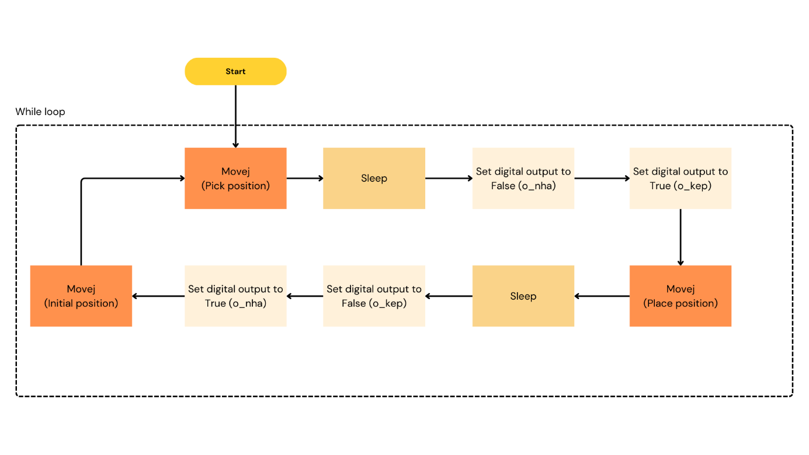

Figure 4.3. Diagram of deploying problems

Similarly to Test Case 3, a similar prompt format was used for this problem. The results obtained were comparable to those of Test Case 3, with the primary difference being the addition of information (setting the digital output for two pins):

***Prompt***: Define a URscript function can move UR robot between 2 waypoints linear in tool-space given tool position and joint position of waypoint_1 are [-0.13, -0.26, 0.14, -0.001, 3.11, 0.03] and [-1.6, -1.72, -2.2, -0.8, 1.59, -0.03], tool position and joint position of waypoint_2 are [-0.008, -0.26, 0.28, -0.27, -2.71, 0.217] and [-0.92, -1.26,-1.88, -1.73, 1.16, 0.88], joint acceleration and joint speed are 1.39 radian/s^2 and 1.04 radian/s with waypoint_1, 0.78 radian/s^2 and 0.87 radian/s with waypoint_2, we use active TCP, in waypont_2, using set_digital_out(0, True) and set_digital_out(1, False), then move to waypoint 1, using set_digital_out(0, False) and set_digital_out(1, True)

***Qwen-Coder-7B result*:**

def move_linear():

local Waypoint_1_p=p[-0.13, -0.26, 0.14, -0.001, 3.11, 0.03]

local Waypoint_1_q=[-1.6, -1.72, -2.2, -0.8, 1.59, -0.03] # radian

local Waypoint_2_p=p[-0.008, -0.26, 0.28, -0.27, -2.71, 0.217]

local Waypoint_2_q=[-0.92, -1.26, -1.88, -1.73, 1.16, 0.88] # radian

while (True):

movep(Waypoint_1_p, a=1.39, v=1.04, r=0.025)

set_digital_out(0, True)

set_digital_out(1, False)

movep(Waypoint_2_p, a=0.78, v=0.87, r=0.025)

set_digital_out(0, False)

set_digital_out(1, True)

end

end

```

### Explaination:

1. `Waypoint_1_p`: tool position or pose (x, y, x, Rx, Ry, Rz) of waypoint_1

2. `Waypoint_1_q`: joint position (Base, Shoulder, Elbow, Wrist 1, Wrist 2) of waypoint_1

3. `Waypoint_2_p`: tool position (x, y, x, Rx, Ry, Rz) of waypoint_2

4. `Waypoint_2_q`: joint position (Base, Shoulder, Elbow, Wrist 1, Wrist 2) of waypoint_2

5. `movep()`: command move robot to position linear in tool-space and spherical in joint-space, given joint acceleration(a), joint speed(v) and blend radius (r)

6. `set_digital_out()`: set the digital output to desired value (True or False)

You can modify the necessary parameters such as joint positions, tool positions, or the velocity and acceleration of the movep() function.

Figure 4.4 showing a depicts an industrial robotic system featuring a Universal Robots (UR) collaborative robot (cobot). This is system where we deploying URscript code, some main components we should focus are:

(1). **UR3 robo**t are mounted on the system, these arm are equipped with grippers, used for manipulating objects or performing tasks along the assembly line.

(2). **HMI touchscreen**: which enables users to interact with the robotic system. It provides a user-friendly interface to verify and manage the **TCP/IP connection** between the system and a computer or network.

(3). A **gateway network**, enabling external communication with the robotic arms and the workstation's control system. This gateway serves as an intermediary for data exchange between the robot controller and external devices or systems over a TCP/IP network.

(4). **Workpiece**: The system is designed to handle workpieces using the robotic gripper. A workpiece refers to the material or component that the cobot manipulates during operations. The gripper securely contacts and positions the workpiece for tasks such as assembly, inspection, or machining, ensuring precision and repeatability in industrial processes.

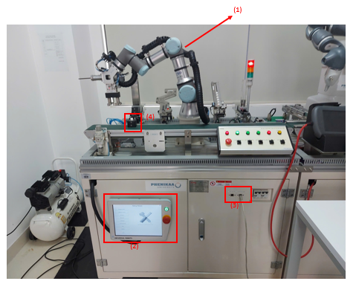

Figure 4.4. UR System for deploying URscript

1. State 1: The clamp arm is in the initial position

The robotic arm is equipped with a gripper (clamp arm), which is in the **initial or standby position**, hovering above the workpiece area. The gripper is ready to pick up or manipulate objects placed on the conveyor or workstation.

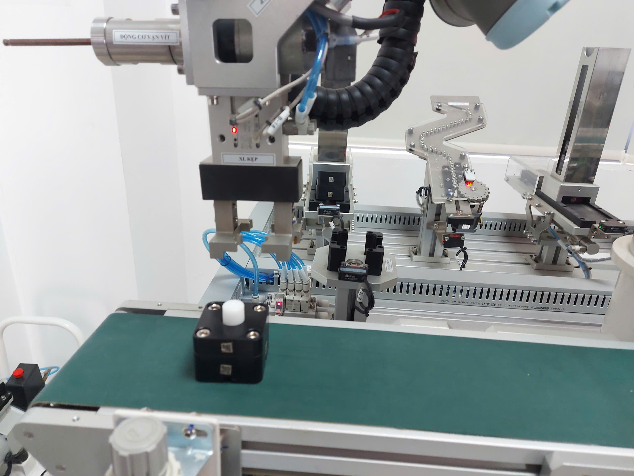

Figure 4.5. State 1 of deploying

2. State 2: The clamping arm moves to the position where the workpiece needs to be picked up

The robotic **clamping arm** is positioned precisely above the **workpiece**, ready to engage and grip it. The gripper is aligned directly with the object on the conveyor belt, demonstrating the system's precision and accuracy.

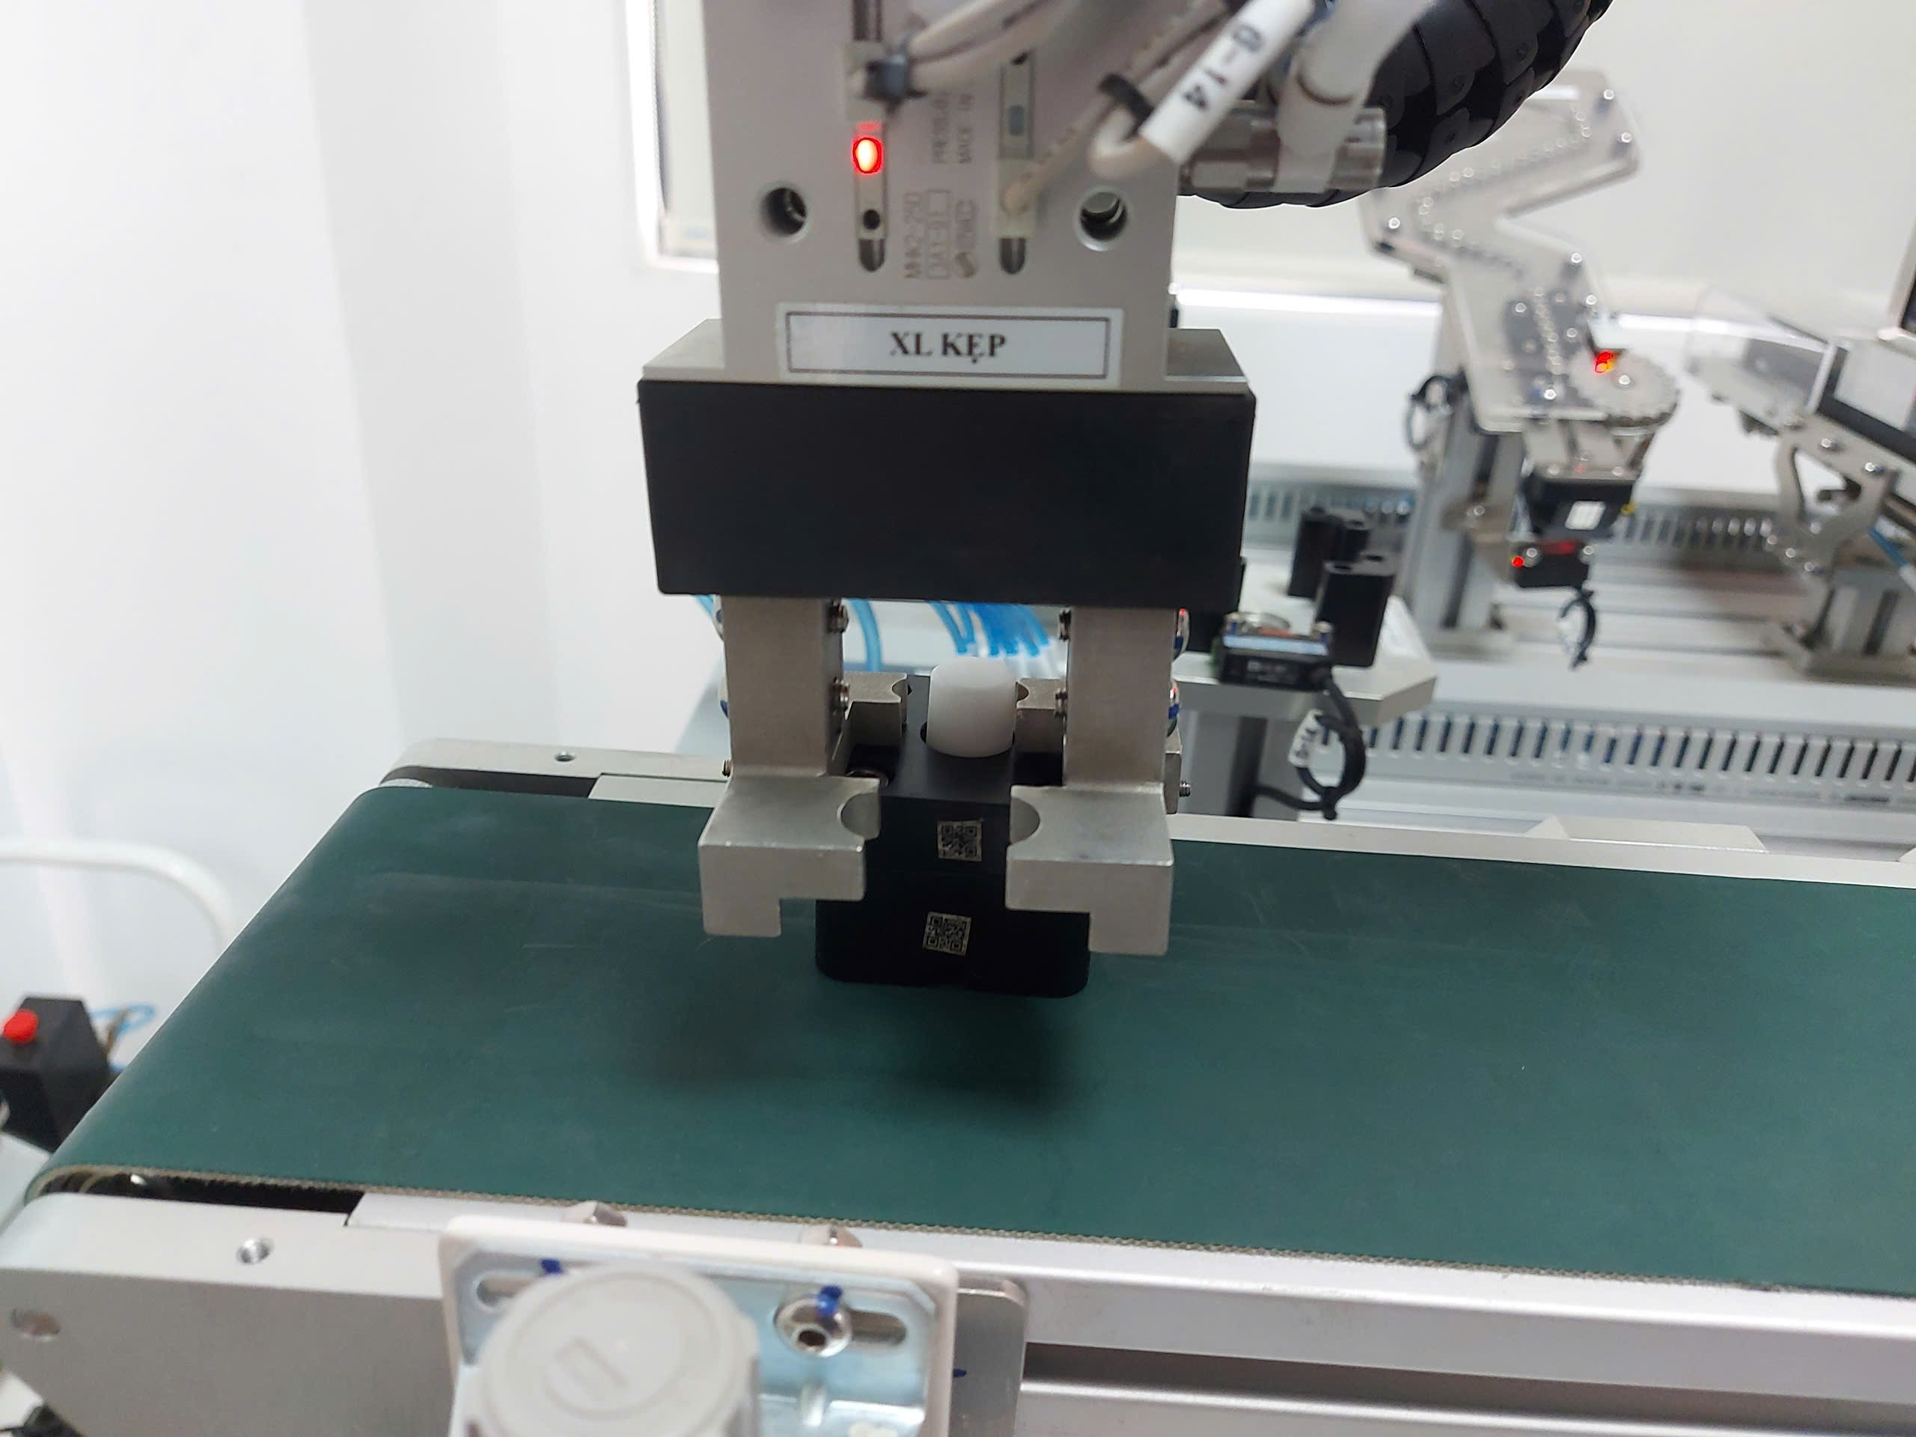

Figure 4.6. State 2 of deploying

3. State 3: The gripper performs the picking operation

During picking operation, the gripper utilize **pneumatic** **actuation** for controlled clamping force during operation. By adjusting the pneumatic pressure, the system can adapt to different workpiece sizes and materials, preventing damage to fragile components while maintaining a firm hold.

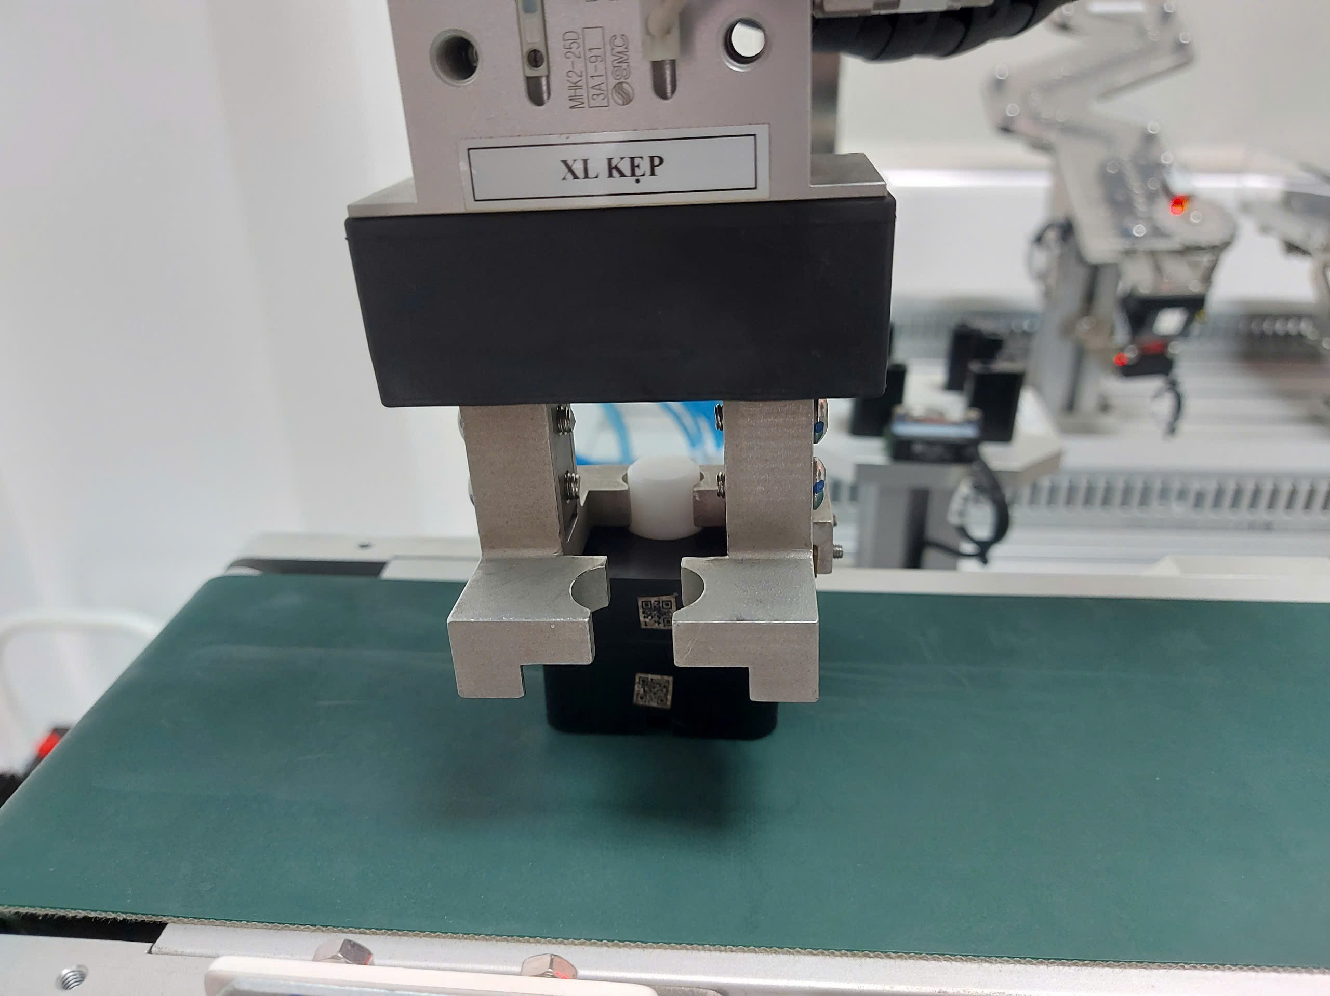

Figure 4.7. State 3 of deploying

4. State 4: The clamp brings the workpiece to the target position

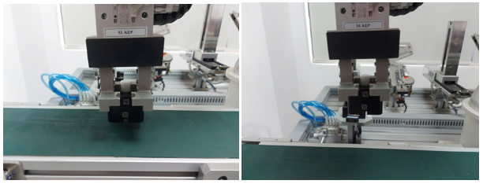

Figure 4.8. State 4 of deploying

5. State 5: The clamp releases the workpiece

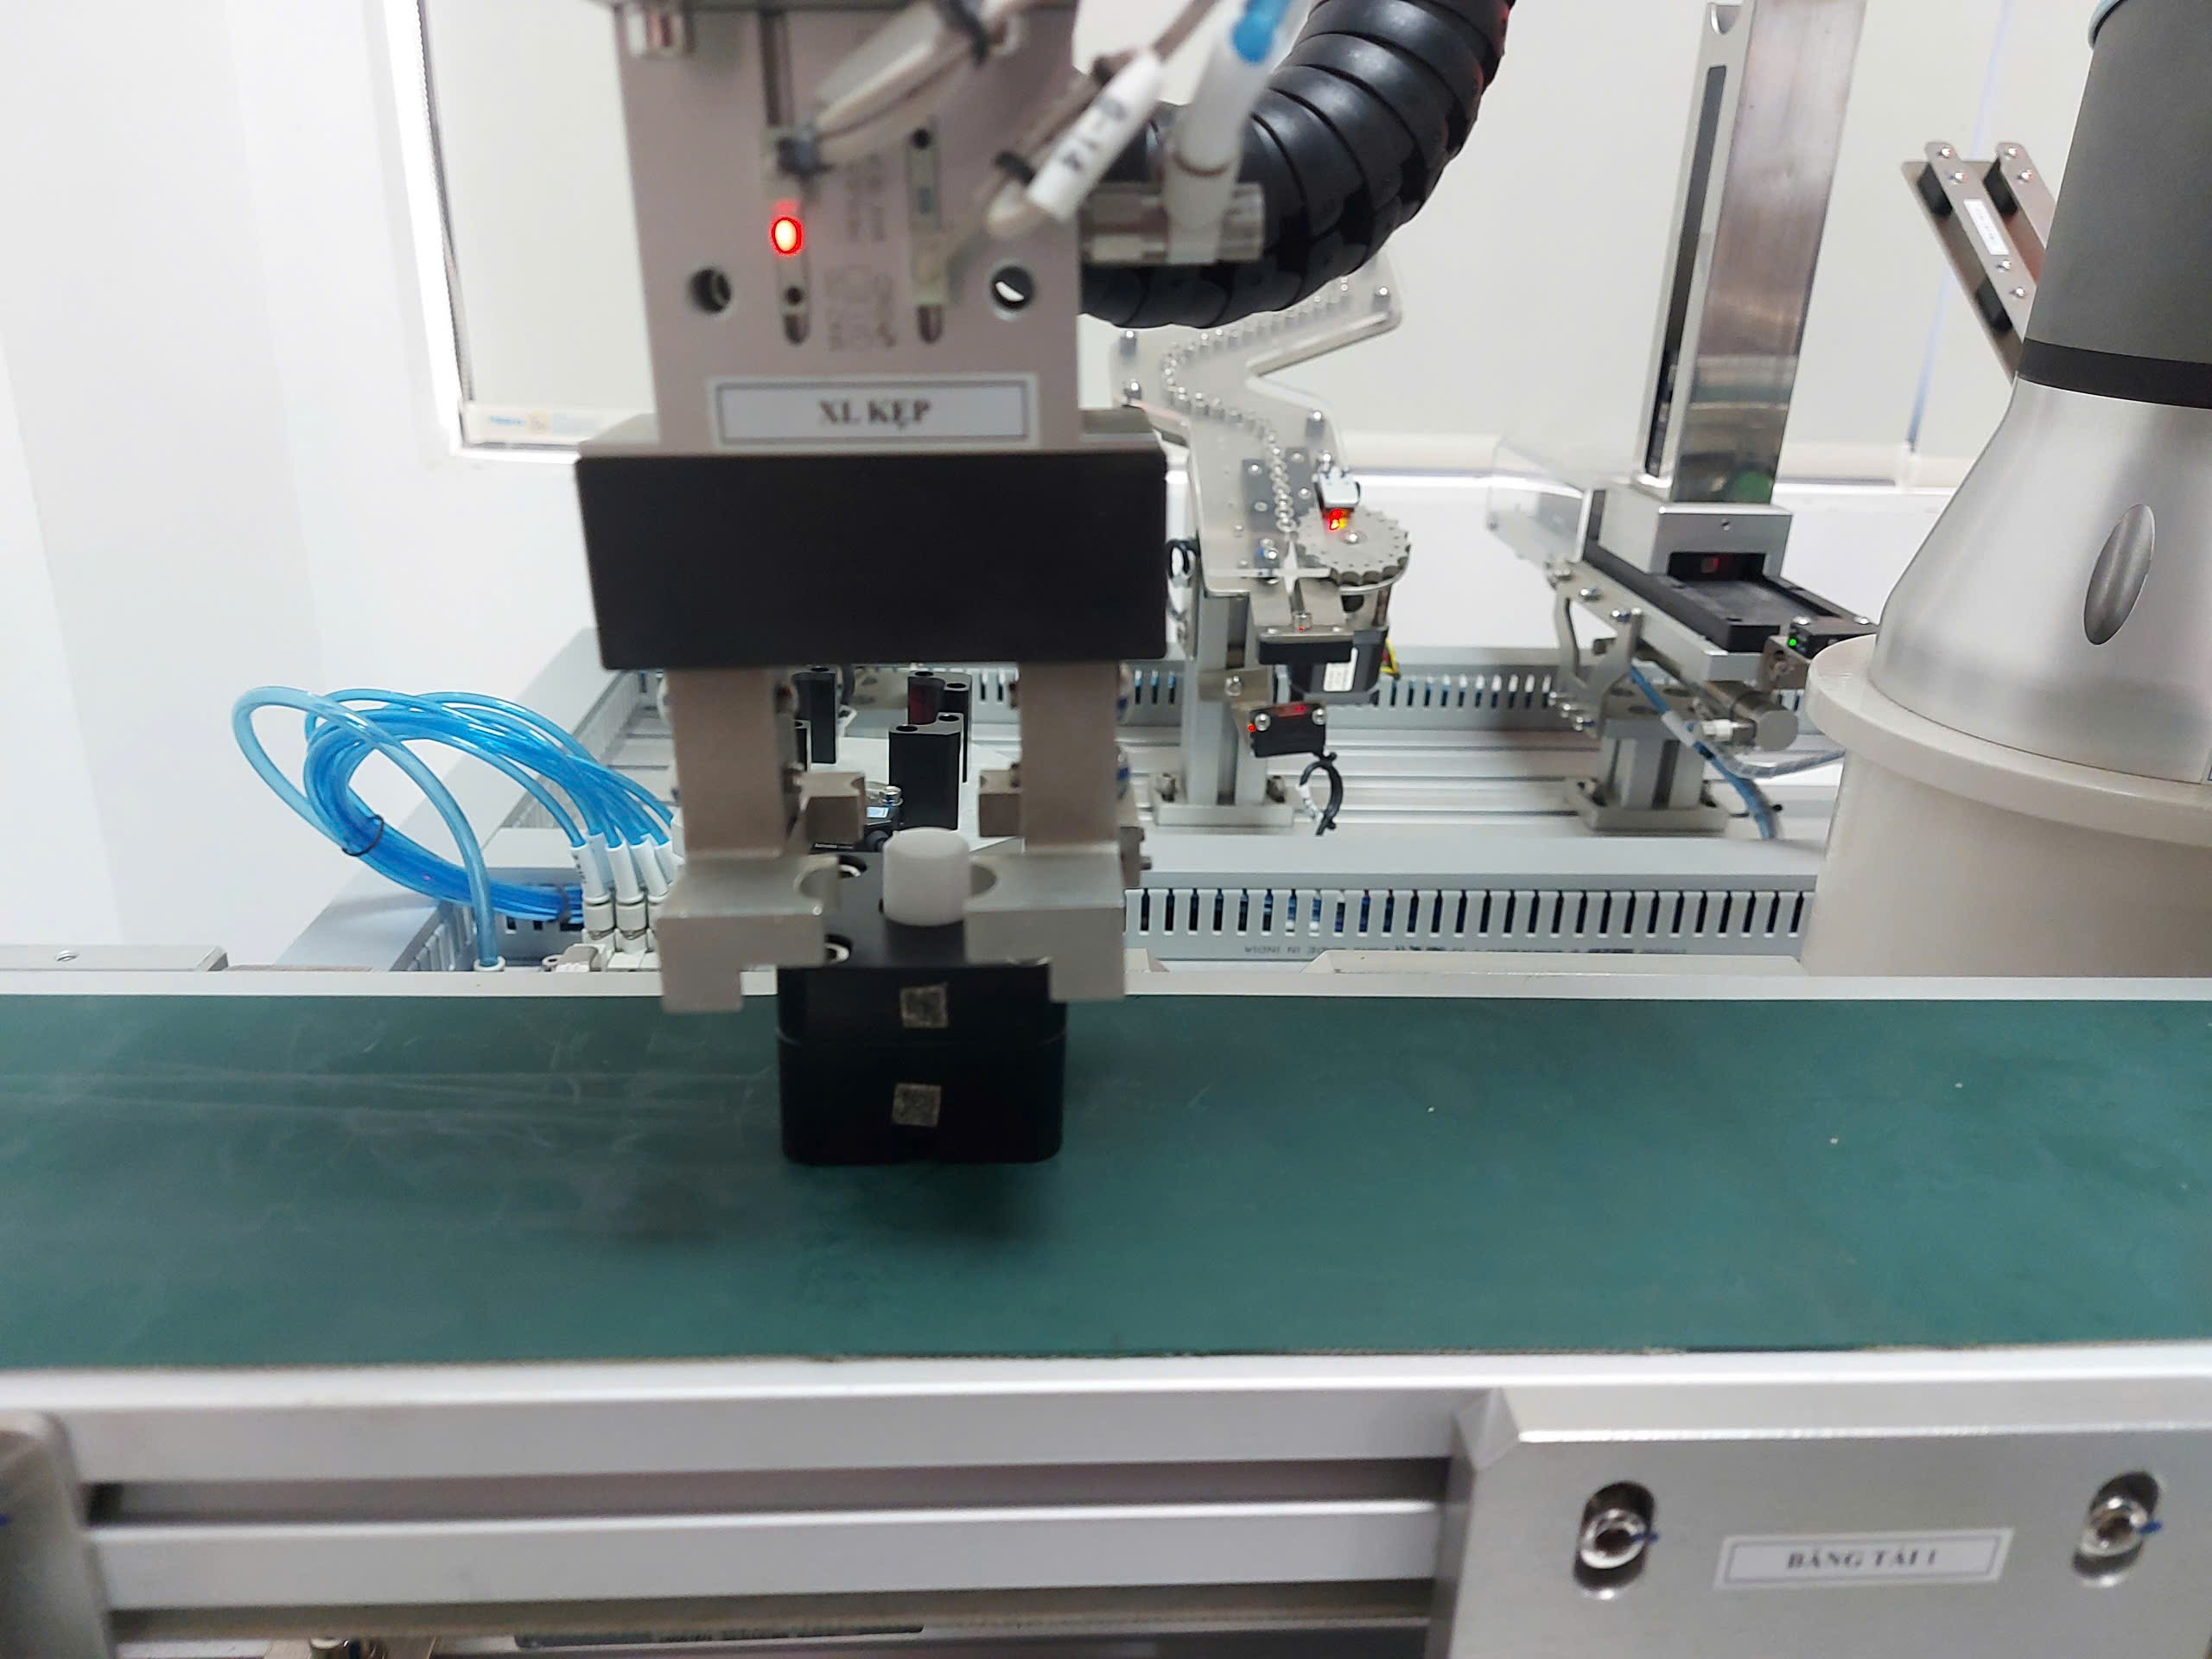

Figure 4.9. State 5 of deploying

6. State 6: The clamp arm returns to its original position

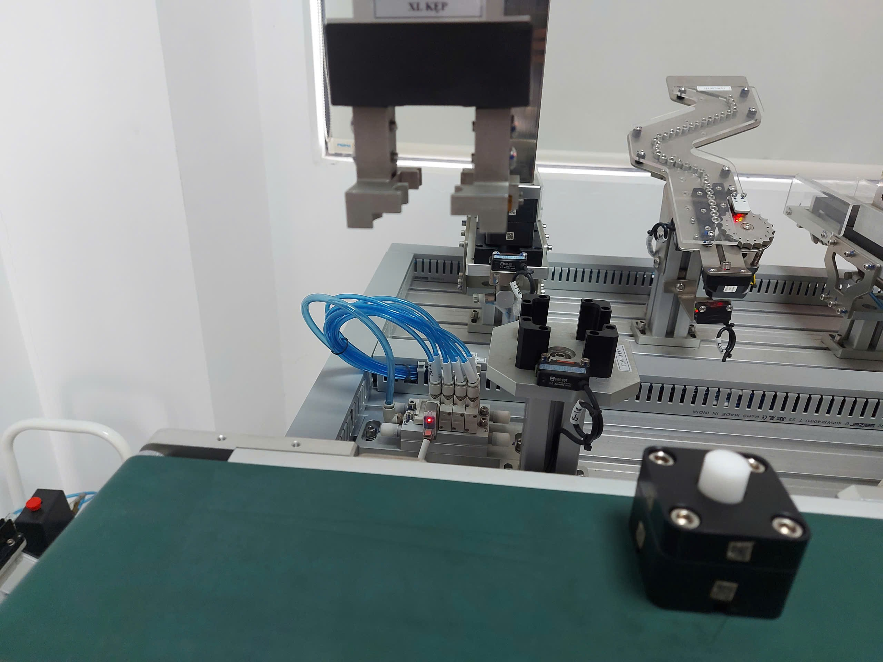

Figure 4.10. State 6 of deploying

## V. CONCLUSION

This research explored the fine-tuning of large language models (LLMs) for generating URScript code, focusing on their ability to understand and implement logical reasoning within robotic programming tasks. A custom dataset, carefully crafted by hand and validated using URSim, provided the foundation for training and testing the models. Five test cases were designed to evaluate the logical comprehension of the fine-tuned models, reflecting real-world scenarios in robotic control.

The experimental results demonstrated that larger, code-oriented models, such as Qwen2.5-Coder-7B, exhibited better logical understanding and performance across the test cases compared to smaller models. However, even the best-performing model faced challenges in handling more complex logical tasks, indicating room for improvement in fine-tuning strategies and dataset design. Finally, the generated URScript code was deployed on a physical UR3 robotic arm to assess real-world applicability. The deployment validated the functional accuracy of the code in simpler scenarios but also highlighted the limitations of current LLMs in translating abstract logical tasks into robust robotic actions. This research underscores the importance of high-quality, domain-specific datasets and emphasizes the potential of LLMs for robotic programming, while pointing to the need for further advancements in model fine-tuning and testing methodologies.

# References

[1] “Big Code Models Leaderboard - a Hugging Face Space by bigcode — huggingface.co.” [Online]. Available: https://huggingface.co/spaces/bigcode/ bigcode-models-leaderboard

[2] U. Robots, “Universal Robots Unveils Its AI Accelerator.” [Online]. Available: https://www.universal-robots.com/about-universal-robots/news-centre/ universal-robots-unveils-its-ai-accelerator/

[3] D. A. Boumber, F. Z. Qachfar, and R. Verma, “Domain-Agnostic Adapter Architecture for Deception Detection: Extensive Evaluations with the DIFrauD Benchmark,” in Proceedings of the 2024 Joint International Conference on Computational Linguistics, Language Resources and Evaluation (LREC-COLING 2024), N. Calzolari, M.-Y. Kan, V. Hoste, A. Lenci, S. Sakti, and N. Xue, Eds., Torino, Italia: ELRA, ICCL, May 2024, pp. 5260–5274. [Online]. Available: <https://aclanthology.org/2024.lrec-main.468>

[4] “Offline Simulator - UR Sim for non Linux 5.12.6 LTS — universal robots.com.” [Online]. Available: https://www.universal-robots.com/download/ software-e-series/simulator-non-linux/offline-simulator-e-series-ur-sim-for non-linux-5126-lts/

[5] A. Vaswani et al., “Attention is All You Need,” in Advances in Neural Information Processing Systems (NeurIPS), 2017, pp. 5998–6008.

[6] A. Radford, K. Narasimhan, T. Salimans, and I. Sutskever, “Improving Language Understanding by Generative Pretraining,” 2018.

[7] J. Devlin, M.-W. Chang, K. Lee, and K. Toutanova, “BERT: Pre-training of Deep Bidirectional Transformers for Language Understanding,” in Proceedings of the North American Chapter of the Association for Computational Linguistics (NAACL), 2019, pp. 4171–4186.

[8] T. Brown et al., “Language Models are Few-Shot Learners,” in Advances in Neural Information Processing Systems (NeurIPS), 2020, pp. 1877–1901.

[9] J. Howard and S. Ruder, “Universal Language Model Fine-tuning for Text Classification,” in Proceedings of the Association for Computational Linguistics (ACL), 2018, pp. 328–339.

[10] E. M. Bender, T. Gebru, A. McMillan-Major, and S. Shmitchell, “On the Dangers of Stochastic Parrots: Can Language Models Be Too Big?,” in Proceedings of the 2021 ACM Conference on Fairness, Accountability, and Transparency (FAccT), 2021, pp. 610–623. doi: 10.1145/3442188.3445922.

[11] A. C. Q. Team, “Introducing Qwen Language Models.” 2023.

[12] B. Hui et al., “Qwen2.5-Coder Technical Report,” arXiv preprint arXiv:2409.12186, 2024.

[13] Y. An et al., “Qwen2 Technical Report,” arXiv preprint arXiv:2309.16609, 2023.

[14] U. R. A/S, “URScript Programming Manual for e-Series.” 2024. [Online]. Available: <https://www.universal-robots.com/>

[15] U. R. A/S, “URSim Offline Simulator Guide.” 2024. [Online]. Available: https:// [www.universal-robots.com/](http://www.universal-robots.com/)

[16] U. R. Forum, “Simulator to Robot Programming Workflow with URScript,” 2024, [Online]. Available: <https://forum.universal-robots.com/>

[17] R. D. Right, “Universal Robots UR3 Datasheet.” [Online]. Available: https://robot sdoneright.com/Universal/Universal-UR3.html